

Anekant Education Society’s
Tuljaram Chaturchand College
Of Arts , Science And Commerce ,Baramati
(Autonomous)

A Project Report on

“ A Study of TREND of Electronic PAYMENT In India”

Submitted To
DEPARTMENT OF STATISTICS

By
T.Y.B.Sc.
Year 2022-2023
CERTIFICATE
This is certify that, Miss. Mane Prapti Bapurao,Miss. Hole Nisha Dada, Miss. Jadhav Reshma Rajendra, Miss. Jadhav Shivanjali Nitin, Miss. Kumbhar Tejashri Dadaso has done this project of “ A Study of Trend of Electronic Payment In India” In the partial fulfillment of Bachelor Degree of Science of Savitribai Phule Pune University, Pune during the academic year 2020-2021. This project represents his sincere work carried out under my guidance. Their project work is satisfactory.

Prof. Dr. Vikas C. Kakade Prof. Dr. Avinash S. Jagtap
Project Guide Examiner H.O.D
Dept. of Statistics.

ACKNOWLEDGMENT
We have satisfaction upon the completion of this project work entitled “A Study of Trend of Electronic Payment In India” at Department of Statistics of “Tuljaram Chaturchand College of Art, Science and Commerce, Baramati” during the academic year 2022-2023.
We take this opportunity to express our sense of gratitude to Prof. Dr. V. C. Kakade for his valuable guidance and help provided us during the course for the completion of the project. We are also very thankful to Mr. Saurabh Kadam, Vice President, Core Risk Modeling, JP Morgan Chase and CO. Mumbai who provide the theme of a project idea and continue support to complete this project.
We are very thankful to Prof. Dr. A.S. Jagtap (Head of the Department of Statistics) for providing all necessary facilities and their encouragement doing this project work. We are thankful to Dr. Mrs. N.K. Dhane and Dr. Mrs. V. V. Patil and Mr.C.P.Swami for their valuable discussion during completion of the project. We also thank all staff members and our classmates and friends at department for their good co-operation.
Last but not least, we would like to thanks non-teaching staff of our Department of Statistics for their cooperation regarding the lab facilities.

THANKS AGAIN TO ALL WHO HELPED US!!
Miss. Mane Prapti Bapurao Miss. Jadhav Shivanjali Nitin
Miss.Hole Nisha Dada Miss. Jadhav Reshma Rajendra
Miss. Kumbhar Tejashri Dadaso
Index

SR. NO. | TITLE | PAGE NO
1. | Abstract & Keywords
2. | Introduction
3. | Objectives
4. | Methodology
5. | Explanatory Data Analysis
6. | Statistical Analysis
7. | Conclusion
8. | Scope and Limitation
9. | References

Abstract
Over the past few years. The popularity of e-commerce has increased dramatically. As business and customers alike are preferring online shopping over traditional in-person shopping trips, online payments using various apps provided by banks (mobile banking, net banking etc…), apps provided by private financial commercial companies and so on. There is need to study the trend of e-payment of various organization, popular banks (public sector/private/payment bank etc) across channels is available for e-payment.
In this study we observed that there is highly intensity of payments for outward as well inward NEFT, outward as well inward RTGS and MOBILE BANKING in the month of March, October and December for all the three banks. The special conclusion from these seasonal indices that there is highly intensity of payments for the bank AXIS bank.
Also, we observe that there is low intensity of payments in private bank than public bank.
The intensity of payments for outward as well inward NEFT, outward as well inward RTGS and MOBILE BANKING in the month of January, February, March, October and December for all the three banks. The special conclusion from these seasonal indices that there is highly and consistent intensity of payments for the bank CANARA bank.
We use Time series Analysis, for statistical analysis. Also, we apply MS-Excel for data analysis.
Keyword: NEFT, RTGS, Mobile Banking, Time Series.

Introduction
With the advent of technology, the banking sector has also changed, and one of the primary concerns that technology has solved is the transfer of funds from one bank account to another. These days, the fastest way to send money is through mobile banking using e-wallets, but one has to use the online mode to send huge amounts. There is a limitation when it comes to doing a financial transaction on mobile. In India, there are different ways to transfer money online based on the amount and settlement timings.
RTGS, NEFT, IMPS are different ways through which you can transfer funds. To transfer funds online you must have internet banking credentials of your savings or current account. Once you log in, you must first register or add beneficiary information if you are doing NEFT/IMPS/RTGS online. Once it is added, you can use any of the methods to transfer funds. But which is a better mode to transfer funds? It depends on the amount you want to transfer and the timing of the transfer. Let us understand more to know which is a better mode to transfer funds.
National Electronic Fund Transfer (NEFT)
National Electronic Fund Transfer (NEFT) The National Electronic Fund Transfer System (NEFT) is an electronic fund transfer system that settles transactions in batches. NEFT service can be availed in a bank branch using cash, cheque, or a DD. Also, it can be using a net banking facility from your bank account. The maximum amount you can submit through NEFT in cash is Rs 50,000.
Banks have been instructed not to charge their savings bank account holders any fees for NEFT funds transactions initiated online from January 1, 2020. NEFT facilities are now available all the time, i.e. 24×7, 365 days. If you want to process NEFT at a bank, you'll have to pay fees depending on the various slabs.

Real-Time Gross Settlement (RTGS)
Real-Time Gross Settlement (RTGS) It is the method of settling funds in real-time, on an order-by-order basis. To put it another way, the request to move or settle funds is handled directly rather than in batches as it is done in NEFT. The RTGS framework is optimized for high-volume transactions. As a result, the minimum amount that can be sent via RTGS in a single day is Rs 2 lakh. The maximum amount per day is Rs 10 lakh. On a working day, banks will use the RTGS service window for consumer transactions from 8 a.m. to 6 p.m. Banks charge service charges for the amount depending on the value of the transaction. The charges differ with different banks and the timing of transactions. SBI Charge on RTGS SBI charges for a transaction between 9 AM to 12 PM are Rs. 25 for a transaction between Rs 2 lakh to Rs 5 lakh. Above Rs 5 lakh is Rs. 51. SBI charges for a transaction between 12 PM to 3:30 PM is Rs. 26 transactions between Rs 2 lakh to Rs 5 lakh and for transactions above Rs 5, it charges Rs 52. SBI charges for a transaction between 3:30 PM to 4:30 PM is Rs. 31 for a transaction between Rs 2 lakh to Rs 5 lakh. Above Rs 5 lakh is Rs. 56.
Immediate Payment Service (IMPS)
Immediate Payment Service (IMPS) Even on Sundays and holidays, IMPS is available 24 hours a day, seven days a week. It is a perfect banking network in case of an emergency because it transfers funds instantly. The regular IMPS fund transfer cap is Rs. 2 lakh. In IMPS, the minimum transaction value is Rupee 1. If transfers are made using a mobile number and MMID, the maximum limit is only Rs 10,000. The IMPS fund transfer is managed by the National Payments Corporation of India (NPCI). Individual banks set their own fees for remittances through IMPS. Please check with your financial institution. HDFC Bank Charges: 1) Above Rs.1 to Rs 1 Lakh - Rs.5 + GST 2) Above 1 lakh to 2 Lakh - Rs.15 + GST. GST is 18%.
Unified Payments Interface (UPI)
Unified Payments Interface (UPI) UPI is a mobile-based instant real-time payment system for transferring funds between bank accounts. UPI enables bank account holders from different banks to send and receive money using only their Aadhaar unique identification number, mobile phone number, or virtual payment address, without having to enter bank account details. Popular UPI apps are BHIM PhonePe Google Pay
Comparing NEFT, RTGS, IMPS, UPI
Description | NEFT | RTGS | IMPS | UPI
Full Form | National | Real-Time | Immediate | Unified
 | electronic fund | Gross | mobile payment | payment
 | Transfer | Settlement | service | interface
Regulated by | RBI | RBI | NPCI | NPCI
Settlement | half hourly | Immediate | Immediate | Immediate
Type | Batches | Settlement | settlement | settlement
Minimum | Rs.1 | Rs.2 lakh | Rs.5 | Rs.1
Transfer
Maximum | No limit | No limit | Rs.2 lakh | Rs.1 lakh
Transfer
Payment option | Online and offline | Online and offline | Online | Online
Timings | In batches-24/7 | Weekdays: | 24/7,365 DAYS | 24/7,365 DAYS
 |  | 9:00AM-4:30PM
Charges | No charges | Charges differ | Differs | No charges
 |  | with bank and
 |  | Amount

Objectives

- Identify the popular sector of bank (private/public) through intensity of various mode of e-payment.

- Identify the popular payment option (like NEFT, RTFS, mobile banking)

- Forecasting of monthly volume of transactions through various mode of e-payment.

- Study of seasonality in data during festival times / ecommerce sales day

Methodology
The National Payment Corporation of India (NPCI) has a sound data repository of payment data across Different channels. The data is available on their official website.
We collect the data from the official websites :

Statistics of NPCI - National Payments Corporation of India
Reserve Bank of India - Bankwise Volumes in ECS/NEFT/RTGS/Mobile Transactions (rbi.org.in)
Reserve Bank of India - Bankwise ATM/POS/Card Statistics (rbi.org.in)
BD TD and Uptime (npci.org.in)

The data is available for the year January 2014 to December 2021 month wise for different bank sectors like private as well public. We consider on three private (ICICI, HDFC, AXIS) banks and the public (SBI, CANARA, BARODA) banks.

We arrange the data month wise for the different bank (Private/Public) NEFT, RTGS, mobile banking for particular purpose.

Explanatory Data Analysis
Private Sector Bank:
NEFT, RTGS and Mobile transactions for AXIS BANK

YEAR | MONTH | NEFT |  | RTGS |  | Mobile
YEAR | MONTH | Total outward debit | Total inward credit | Inward | Outward | Volume
 |  |  |  | Volume | Volume | Volume
YEAR | MONTH | No. of Transaction | No. of Transaction | Customer | Customer
2014 | Jan | 5044776 | 2825319 | 412570 | 390212 | 1292326
2014 | Feb | 4690893 | 2715362 | 384901 | 372497 | 1281063
2014 | Mar | 5588482 | 3318763 | 504144 | 483342 | 1636647
2014 | Apr | 5221322 | 2940664 | 417960 | 404265 | 1670906
2014 | May | 5082306 | 3082523 | 452451 | 432316 | 1567606
2014 | Jun | 4775465 | 3042291 | 438206 | 412139 | 1360367
2014 | Jul | 5308961 | 3297218 | 497 | 924 | 1449571
2014 | Aug | 5341574 | 2968118 | 416516 | 392290 | 1625452
2014 | Sep | 6151490 | 3618864 | 482325 | 428453 | 1667925
2014 | Oct | 6156584 | 3379452 | 434719 | 393698 | 1800697
2014 | Nov | 5440017 | 3249456 | 452833 | 406719 | 1790700
2014 | Dec | 6251281 | 3737718 | 496660 | 455636 | 1952110
2015 | Jan | 6153907 | 3615576 | 471622 | 439103 | 2034428
2015 | Feb | 5945605 | 3344360 | 459849 | 421781 | 2105755
2015 | Mar | 6961190 | 465250.88 | 594136 | 525287 | 2646483
2015 | Apr | 6597825 | 3615278 | 468895 | 424648 | 2671656
2015 | May | 6002662 | 3673989 | 470223 | 431243 | 2922049
2015 | Jun | 6271011 | 3941333 | 491150 | 443323 | 2900563
2015 | Jul | 7076216 | 4069337 | 509470 | 448079 | 3264967
2015 | Aug | 7878238 | 4260722 | 483237 | 423512 | 3423414
2015 | Sep | 7602991 | 4211658 | 476492 | 411304 | 4072649
2015 | Oct | 8344612 | 4641901 | 504347 | 450611 | 4429296
2015 | Nov | 7053140 | 4207452 | 477025 | 403641 | 4996574
2015 | Dec | 7962682 | 4855627 | 504815 | 417915 | 6028436
2016 | Jan | 9115755 | 4689103 | 499851 | 449170 | 6322610
2016 | Feb | 8395870 | 4582165 | 485017 | 462417 | 7265659
2016 | Mar | 9438621 | 5653436 | 590217 | 545563 | 7896459
2016 | Apr | 9703422 | 4826840 | 486987 | 445120 | 7875403
2016 | May | 8769005 | 4908467 | 520188 | 470928 | 8201378
2016 | Jun | 9379483 | 5119135 | 530451 | 483002 | 8207877
2016 | Jul | 9330629 | 5040659 | 502444 | 471061 | 8446405
2016 | Aug | 10156807 | 5175549 | 526537 | 486803 | 8540962
2016 | Sep | 11244781 | 5183756 | 533064 | 471826 | 8663571
2016 | Oct | 13789791 | 5975538 | 582416 | 496039 | 9199760
2016 | Nov | 14518712 | 5756040 | 507301 | 422785 | 9837562
2016 | Dec | 15732438 | 7581842 | 525017 | 456939 | 12282565
2017 | Jan | 14400888 | 7271930 | 560399 | 474040 | 11630395
2017 | Feb | 12188636 | 6536245 | 565881 | 481108 | 10509182
2017 | Mar | 15591958 | 7801133 | 793037 | 636893 | 11022673
2017 | Apr | 13707599 | 6432024 | 604914 | 505107 | 10403128
2017 | May | 13342651 | 6793429 | 683730 | 544005 | 10681111
2017 | Jun | 11805748 | 11805748 | 649136 | 512425 | 10359147
2017 | Jul | 12918109 | 6736419 | 613369 | 506058 | 10963537
2017 | Aug | 12254042 | 6882967 | 618853 | 502765 | 10852105
2017 | Sep | 13049171 | 7232115 | 631421 | 509929 | 16861519
2017 | Oct | 14046451 | 7498291 | 661620 | 532853 | 31244615
2017 | Nov | 13962339 | 7666393 | 722192 | 575228 | 35372815
2017 | Dec | 15032891 | 7801424 | 734132 | 574174 | 33217677
2018 | Jan | 15037690 | 7883571 | 740368 | 600900 | 27433165
2018 | Feb | 14890993 | 7627592 | 708070 | 571613 | 27127489
2018 | Mar | 27127489 | 9062627 | 854280 | 673123 | 31096314
2018 | Apr | 15607810 | 7807548 | 720363 | 720363 | 29555222
2018 | May | 15304157 | 8359125 | 786991 | 638497 | 32724863
2018 | Jun | 15789609 | 8444765 | 789476 | 608159 | 32897166
2018 | Jul | 16294373 | 8438896 | 768104 | 602373 | 36738870
2018 | Aug | 16081675 | 8679464 | 785992 | 601525 | 42237848
2018 | Sep | 15321590 | 8279505 | 733695 | 572094 | 62937451
2018 | Oct | 17781275 | 9397837 | 828194 | 659570 | 73616393
2018 | Nov | 17670621 | 8867019 | 779303 | 615174 | 86398872
2018 | Dec | 16102160 | 9202210 | 800209 | 633258 | 91518285
2019 | Jan | 17906578 | 9482091 | 831669 | 666409 | 81738155
2019 | Feb | 17146212 | 17146212 | 787211 | 647765 | 76835458
2019 | Mar | 21216532 | 10628825 | 975469 | 774191 | 83925325
2019 | Apr | 17778807 | 9364107 | 827959 | 643390 | 79545727
2019 | May | 19005558 | 10102164 | 915244 | 716558 | 71204025
2019 | Jun | 15886343 | 9170701 | 843194 | 695323 | 88383460
2019 | Jul | 18603582 | 10084874 | 908253 | 773481 | 99571865
2019 | Aug | 19137383 | 10059172 | 849522 | 724724 | 102810530
2019 | Sep | 16593165 | 9585610 | 821112 | 687840 | 111437590
2019 | Oct | 19965322 | 10688456 | 926511 | 771306 | 133779005
2019 | Nov | 17672383 | 10128342 | 980538 | 807235 | 136938076
2019 | Dec | 19382701 | 10610990 | 986250 | 821953 | 149390862
2020 | Jan | 21427979 | 11219097 | 987486 | 848863 | 154965325
2020 | Feb | 22882103 | 10925662 | 955538 | 811503 | 140756362
2020 | Mar | 22463234 | 11259978 | 866507 | 732460 | 137658301
2020 | Apr | 13618010 | 7343483 | 388587 | 309562 | 116353675
2020 | May | 16149828 | 8741939 | 661726 | 503351 | 269463941
2020 | Jun | 18192398 | 10125729 | 875411 | 645570 | 267954268
2020 | Jul | 21213116 | 11335164 | 931684 | 711646 | 296405538
2020 | Aug | 21291459 | 10976232 | 862064 | 696401 | 373934646
2020 | Sep | 20902325 | 11810236 | 954438 | 808809 | 296634072
2020 | Oct | 23748741 | 13575452 | 1017163 | 845224 | 371485531
2020 | Nov | 23146957 | 13082412 | 1030166 | 858264 | 420483683
2020 | Dec | 24518581 | 13993030 | 1217765 | 1006698 | 379596749
2021 | Jan | 22968074 | 13249717 | 1179358 | 953629 | 382066331
2021 | Feb | 22580629 | 12613818 | 1189362 | 955789 | 354912422
2021 | Mar | 28571247 | 15801197 | 1529105 | 1225890 | 432459650
2021 | Apr | 22841508 | 13390046 | 1145745 | 902636 | 428177323
2021 | May | 21962015 | 12907407 | 928009 | 746012 | 399411008
2021 | Jun | 23223403 | 13893757 | 1154060 | 939620 | 431779509
2021 | Jul | 25541791 | 14627262 | 1267333 | 1036108 | 502790715
2021 | Aug | 23565827 | 14274596 | 1262128 | 1053823 | 565218189
2021 | Sep | 28376795 | 16033632 | 1326206 | 1107258 | 567928742
2021 | Oct | 546696 | 586065 | 1397998 | 1156524 | 653152147
2021 | Nov | 29179441 | 14990655 | 1184063 | 1000087 | 664925942
2021 | Dec | 31801703 | 16843222 | 1477658 | 1238643 | 728361959
2022 | Jan | 28762146 | 17166503 | 1387428 | 1154892 | 729719620
2022 | Feb | 33139102 | 18880878 | 1383340 | 1164636 | 715886648
2022 | Mar | 35649672 | 22246934 | 1735058 | 1481308 | 856386808
2022 | Apr | 28636018 | 19180760 | 1475128 | 1228219 | 890244715
2022 | May | 32990109 | 19009441 | 1508673 | 1250222 | 959425521
2022 | Jun | 33134660 | 19015645 | 1485926 | 1485926 | 981978711
2022 | Jul | 30232349 | 19452808 | 1457847 | 1223555 | 1032998494
2022 | Aug | 29899350 | 19547582 | 1440618 | 1220611 | 565218189
2022 | Sep | 35810093 | 20303034 | 1552364 | 1294713 | 1073534110
2022 | Oct | 44247532 | 23198902 | 1479120 | 1228201 | 1170638844
2022 | Nov | 45596497 | 21424702 | 1594790 | 1334066 | 1258836551
2022 | Dec | 48916808 | 22808750 | 1650708 | 1417146 | 1429492010

Public Sector Bank:

NEFT, RTGS and Mobile transactions for BRODA BANK
YEAR | MONTH | NEFT |  | RTGS |  | Mobile
YEAR | MONTH | Total Outward Debit | Total inward credit | Inward | Outward | Volume
 |  |  |  | Volume | Volume | Volume
YEAR | MONTH | No. of Transaction | No. of Transaction | Customer | Customer | Volume
2014 | Jan | 1052316 | 2914068 | 230084 | 279473 | 51728
2014 | Feb | 921646 | 2982841 | 215058 | 271845 | 56077
2014 | Mar | 56077 | 4502831 | 299249 | 295506 | 81505
2014 | Apr | 1089300 | 2983772 | 234055 | 301357 | 72705
2014 | May | 1419654 | 2844964 | 249754 | 304999 | 80244
2014 | Jun | 1057486 | 2883174 | 236000 | 279607 | 74245
2014 | Jul | 1325428 | 3089141 | 239006 | 277880 | 80221
2014 | Aug | 1035023 | 2642544 | 214723 | 262163 | 76925
2014 | Sep | 1615402 | 3314745 | 243441 | 288741 | 86535
2014 | Oct | 1319561 | 3162602 | 230469 | 282463 | 91908
2014 | Nov | 910528 | 2732198 | 236783 | 276813 | 91900
2014 | Dec | 1116784 | 3486760 | 270324 | 316220 | 101641
2015 | Jan | 1073126 | 3311988 | 261236 | 308289 | 102677
2015 | Feb | 1075955 | 4066189 | 253815 | 298111 | 125907
2015 | Mar | 1329010 | 5910108 | 342125 | 384880 | 164810
2015 | Apr | 1038872 | 4302520 | 257871 | 310850 | 179951
2015 | May | 1126794 | 3331401 | 257871 | 310850 | 179951
2015 | Jun | 1226772 | 4045628 | 261117 | 317739 | 252935
2015 | Jul | 1284414 | 5638952 | 260925 | 315852 | 315108
2015 | Aug | 1282768 | 3876500 | 241992 | 292012 | 353032
2015 | Sep | 1393718 | 4542336 | 243162 | 293225 | 398611
2015 | Oct | 1591347 | 6345981 | 267503 | 325891 | 443961
2015 | Nov | 1452979 | 5008167 | 240920 | 304935 | 505993
2015 | Dec | 1599914 | 6195271 | 258951 | 317898 | 573786
2016 | Jan | 1563173 | 6588305 | 263917 | 321461 | 655273
2016 | Feb | 1719463 | 5565074 | 265132 | 320660 | 696916
2016 | Mar | 1834027 | 6452776 | 340299 | 388423 | 834097
2016 | Apr | 1595721 | 4453713 | 261702 | 319524 | 817353
2016 | May | 1788834 | 6733540 | 269435 | 331177 | 943050
2016 | Jun | 1767960 | 5899163 | 271824 | 333765 | 976018
2016 | Jul | 1772524 | 5729575 | 253684 | 303621 | 1086821
2016 | Aug | 1799150 | 5962715 | 254882 | 313493 | 1159471
2016 | Sep | 1781264 | 5910239 | 256757 | 312100 | 1221088
2016 | Oct | 2003742 | 6867875 | 282276 | 343997 | 1313579
2016 | Nov | 1920320 | 5645242 | 224715 | 286864 | 1395242
2016 | Dec | 2909928 | 7843582 | 272871 | 323215 | 1552160
2017 | Jan | 3044930 | 7781882 | 299729 | 352541 | 1502563
2017 | Feb | 2572193 | 7008570 | 289869 | 344804 | 1962229
2017 | Mar | 3124940 | 9396071 | 420804 | 490953 | 2196095
2017 | Apr | 2718052 | 6889750 | 297025 | 369486 | 2151314
2017 | May | 2913167 | 7683910 | 318756 | 318756 | 2366203
2017 | Jun | 2723363 | 7455958 | 303143 | 359215 | 2368225
2017 | Jul | 2894384 | 7281655 | 282314 | 331293 | 2585514
2017 | Aug | 2820653 | 7627007 | 275767 | 304354 | 2863201
2017 | Sep | 3500631 | 8210838 | 287014 | 324958 | 3037428
2017 | Oct | 3232242 | 8419961 | 301536 | 345605 | 3454274
2017 | Nov | 3652104 | 8455522 | 327274 | 382757 | 3160759
2017 | Dec | 3488292 | 8617130 | 333988 | 398343 | 3134864
2018 | Jan | 3658751 | 7331450 | 348268 | 414620 | 3313773
2018 | Feb | 3497940 | 7054198 | 332289 | 403151 | 3407093
2018 | Mar | 4408575 | 9782922 | 412129 | 475041 | 3984560
2018 | Apr | 3265324 | 6574473 | 324768 | 404005 | 4099511
2018 | May | 3466867 | 6978698 | 346231 | 427253 | 4458691
2018 | Jun | 3688772 | 7116678 | 343915 | 437206 | 4294856
2018 | Jul | 3656984 | 7346557 | 323765 | 394213 | 4901300
2018 | Aug | 3906574 | 7814690 | 324147 | 409631 | 5601466
2018 | Sep | 3843592 | 7660740 | 300579 | 382280 | 5278837
2018 | Oct | 4437140 | 8799535 | 355610 | 450168 | 5816545
2018 | Nov | 3685814 | 8118631 | 326035 | 392108 | 5718496
2018 | Dec | 3672665 | 8282716 | 342476 | 408619 | 6147017
2019 | Jan | 4040422 | 8711253 | 359210 | 439524 | 6299786
2019 | Feb | 3890390 | 8841430 | 336468 | 404669 | 6183341
2019 | Mar | 4413970 | 11086706 | 432840 | 505351 | 9400600
2019 | Apr | 3759824 | 9809523 | 345462 | 420172 | 11009341
2019 | May | 3418750 | 10681671 | 366653 | 455892 | 8094417
2019 | Jun | 3209160 | 9641092 | 342448 | 453060 | 7832602
2019 | Jul | 3486305 | 10703405 | 368296 | 479122 | 8403726
2019 | Aug | 3174837 | 11710815 | 339228 | 438925 | 8600873
2019 | Sep | 2903339 | 10954753 | 335280 | 414510 | 8401313
2019 | Oct | 3447645 | 12875094 | 386675 | 486091 | 8990210
2019 | Nov | 3215310 | 10865347 | 386803 | 503530 | 8960800
2019 | Dec | 4132563 | 13447966 | 409829 | 516787 | 10013242
2020 | Jan | 4132563 | 13447966 | 409829 | 516787 | 10013242
2020 | Feb | 4230826 | 12882472 | 393643 | 498833 | 9961592
2020 | Mar | 5256949 | 14293401 | 357522 | 540726 | 10951408
2020 | Apr | 3616713 | 9877420 | 151125 | 262298 | 7722923
2020 | May | 4568796 | 10262055 | 256108 | 465108 | 9485963
2020 | Jun | 5382247 | 11715979 | 360003 | 629232 | 10491456
2020 | Jul | 5506915 | 12783762 | 377442 | 636946 | 10555623
2020 | Aug | 4989999 | 12408369 | 349476 | 582280 | 97232148
2020 | Sep | 5519711 | 13482599 | 408554 | 635598 | 101736086
2020 | Oct | 5530053 | 14407461 | 458326 | 687606 | 108768207
2020 | Nov | 5373933 | 14071095 | 459573 | 662718 | 120776095
2020 | Dec | 5987625 | 17310327 | 574177 | 783762 | 128308332
2021 | Jan | 5661142 | 16111352 | 572436 | 741359 | 139210816
2021 | Feb | 5087049 | 16248582 | 575408 | 743661 | 144580828
2021 | Mar | 6668126 | 19569214 | 779396 | 977990 | 159685073
2021 | Apr | 4579131 | 18306849 | 546739 | 702612 | 165845732
2021 | May | 4059880 | 15341165 | 439468 | 564496 | 158969688
2021 | Jun | 5021352 | 17278619 | 564251 | 721592 | 181819637
2021 | Jul | 5520394 | 19448706 | 612157 | 771320 | 211085789
2021 | Aug | 5534394 | 20848550 | 600855 | 749784 | 236118471
2021 | Sep | 5802328 | 21271256 | 632178 | 780279 | 247588652
2021 | Oct | 6030365 | 23429007 | 686006 | 846594 | 273608028
2021 | Nov | 5370843 | 21473165 | 566800 | 712959 | 276074946
2021 | Dec | 5612629 | 24088684 | 713645 | 880565 | 306289828
2022 | Jan | 5500010 | 23761820 | 676750 | 846880 | 315540928
2022 | Feb | 5602808 | 23859005 | 671003 | 850663 | 285218686
2022 | Mar | 7812002 | 30887951 | 901536 | 1092531 | 287628548
2022 | Apr | 6681825 | 24229973 | 735450 | 921653 | 356252425
2022 | May | 6060827 | 24267818 | 711058 | 911493 | 405869402
2022 | Jun | 6074351 | 26678548 | 701854 | 913741 | 359705415
2022 | Jul | 6355209 | 26287587 | 674527 | 871859 | 436476104
2022 | Aug | 6159416 | 28608807 | 660206 | 852140 | 451520401
2022 | Sep | 6548348 | 29872286 | 698678 | 904021 | 469332116
2022 | Oct | 469332116 | 32979341 | 682411 | 875774 | 501392111
2022 | Nov | 6522633 | 31795668 | 753581 | 942837 | 499418679
2022 | Dec | 7111019 | 35100923 | 791108 | 978089 | 443438996

Private Banks:

- Seasonal indices for TOTAL OUTWARD from NEFT for the AXIS BANK

MONTH | 2014 | 2015 | 2016 | 2017 | 2018 | 2019 | 2020 | 2021 | 2022 | NO. OF SEASONAL INDICISES (HIGHLY EXIST)
Jan | - | - | 199.186 | 203.054 | - | 190.075 | 207.772 | - | 191.701 | 5
Feb | - | - | - | - | - | - | 217.683 | - | 214.313 | 2
Mar | - | 199.253 | 197.509 | 211.312 | 296.810 | 216.888 | 212.825 | 219.678 | 226.348 | 8
Apr | - | - | - | - | - | - | - | - | - | -
May | - | - | - | - | - | 193.262 | - | - | - | 1
Jun | - | - | - | - | - | - | - | - | - | -
Jul | - | - | - | - | - | - | - | 199.869 | - | 1
Aug | - | 196.264 | - | - | - | - | - | - | - | 1
Sep | 200.678 | - | - | - | - | - | - | 208.980 | - | 2
Oct | 193.609 | 195.484 | 206.775 | - | 194.229 | 197.001 | 198.576 | - | - | 6
Nov | - | - | 213.341 | - | 190.9785 | - | 192.043 | 206.236 | - | 4
Dec | - | - | 221.675 | - | - | 190.836 | 196.073 | 211.715 | - | 4

- Seasonal indices for TOTAL INWARD from NEFT for the AXIS BANK
MONTH | 2014 | 2015 | 2016 | 2017 | 2018 | 2019 | 2020 | 2021 | 2022 | NO. OF SEASONAL INDICISES (HIGHLY EXIST)
Jan | - | 110.419 | - | 106.157 | - | - | 110.898 | - | 105.494 | 4
Feb | - | - | - | - | - | 169.911 | 107.042 | - | 113.105 | 3
Mar | - | - | 116.170 | 109.130 | 112.085 | 104.172 | 108.920 | 114.687 | 130.169 | 7
Apr | - | 102.815 | - |  | - | - | - | - | 105.326 | 2
May | - | 101.806 | - | - | - | - | - | - | - | 1
Jun | - | 106.658 | - | 156.803 | - | - |  | 105.665 | - | 3
Jul | 102.581 | 107.466 | - | - | - | - | - | 108.908 | - | 3
Aug | - | 109.730 | - | - | - | - | - | 103.027 | - | 2
Sep | 113.776 | 101.469 | - | - | - | - | - | 111.462 | - | 3
Oct | 109.370 | 105.084 | - | - | - | 104.969 | 111.830 | - | - | 4
Nov | 103.398 | - | - | - | -- | - | 104.119 | - | - | 2
Dec | 116.630 | 105.105 | 116.627 | - | - | 105.848 | 108.512 | 106.213 | - | 6

Seasonal indices for TOTAL OUTWARD from RTGS for the AXIS BANK
MONTH | 2014 | 2015 | 2016 | 2017 | 2018 | 2019 | 2020 | 2021 | 2022 | NO. OF SEASONAL INDICISES (HIGHLY EXIST)
Jan | - | 105.666 | - | - | 102.109 | 101.058 | 121.166 | 105.832 | - | 5
Feb | - | - | 101.520 | - | - | - | 116.457 | 102.830 | - | 3
Mar | - | 120.457 | 118.433 | 126.765 | 111.570 | 113.575 | 104.535 | 128.122 | 120.060 | 8
Apr | - | - | - | - | 117.862 | - | - | - | - | 1
May | - | - | - | 105.955 | 103.294 | 101.814 | - |  | - | 3
Jun | - | 101.151 | 102.727 | - | - | - | - | - | 115.829 | 3
Jul | - | 102.506 | - | - | - | 105.218 | - | - | - | 2
Aug | 101.322 | - | 102.559 | - | - | - | - | - | - | 2
Sep | 109.587 | - | - | - | - | - | 104.653 | 103.370 | - | 3
Oct | - | 101.609 | 102.161 | - | 102.778 | 104.374 | 103.313 | 105.583 | - | 6
Nov | 103.130 | - | - | - | - | 112.713 | 100.624 | - | - | 3
Dec | 115.168 | - | - | - | - | 116.551 | 115.011 | 105.532 | - | 4

Seasonal indices for TOTAL INWARD from RTGS for the AXIS BANK

MONTH | 2014 | 2015 | 2016 | 2017 | 2018 | 2019 | 2020 | 2021 | 2022 | NO. OF SEASONAL INDICISES (HIGHLY EXIST)
Jan | - | 103.013 | - | - | 102.609 | - | 115.957 | 106.354 | - | 4
Feb | - | - | - | - | - | - | 112.008 | 104.371 | - | 2
Mar | - | 122.666 | 115.489 | 130.607 | 114.487 | 115.626 | - | 130.502 | 119.844 | 7
Apr | - | - | - | - | - | - | - | - | - | -
May | - | - | - | 109.075 | 102.646 | 105.948 | - | - | 101.865 | 4
Jun | - | - | 101.369 | - | 102.285 | - | - | - | - | 2
Jul | - | 103.177 | - | - | - | 101.567 | 103.095 | - | - | 3
Aug | - | - | - | - | - | - | - | - | - | -
Sep | 114.097 | - | - | - | - | - | - | 102.369 | - | 2
Oct | 101.426 | 101.379 | 104.427 | - | 103.089 | 104.411 | - | 106.084 | - | 6
Nov | 104.952 | - | - | 103.303 | - | 114.215 | - | - | - | 3
Dec | 114.329 | - | - | 103.508 | - | 116.12809 | 112.412 | 106.020 | - | 5

- Seasonal indices for VOLUME (ACTUAL) from MOBILE BANKING for the AXIS BANK

MONTH | 2014 | 2015 | 2016 | 2017 | 2018 | 2019 | 2020 | 2021 | 2022 | NO. OF SEASONAL INDICISES (HIGHLY EXIST)
Jan | - | - | 101.737 | - | - | 108.20318 | - | - | - | 2
Feb | - | - | 109.360 | - | - | - | - | 101.741 | 107.059 | 3
Mar | - | 104.524 | 112.034 | - | - | - | - | - | 105.661 | 3
Apr | - | - | 105.876 | - | - | - | - | - | 107.939 | 2
May | - | - | 104.625 | - | - | - | 113.310 | - | 104.153 | 3
Jun | - | - | - | - | - | - | 103.371 | - | - | 1
Jul | - | - | - | - | - | - | 106.517 | - | - | 1
Aug | - | - | - | - | - | - | 126.049 | - | - | 1
Sep | - | - | - | - | 107.171 | - | - | - | - | 1
Oct | - | - | - | 141.384 | 116.833 | 112.668 | 108.261 | - | - | 5
Nov | - | - | - | 148.528 | 129.540 | 106.540 | 116.301 | - | - | 4
Dec | - | 104.341 | 122.315 | 129.386 | 129.608 | 103.546 | 101.554 | 102.334 | - | 7

Seasonal indices for TOTAL OUTWARD from NEFT for the HDFC BANK
MONTH | 2014 | 2015 | 2016 | 2017 | 2018 | 2019 | 2020 | 2021 | 2022 | NO. OF SEASONAL INDICISES (HIGHLY EXIST)
JAN | _ | _ | _ | 111.944 | 118.871 | 105.119 | 114.292 | 101.965 | _ | 5
FEB | _ | _ | 101.063 | 103.077 | 118.068 | _ | 107.598 | _ | _ | 4
MAR | _ | 111.455 | 119.024 | 124.378 | 139.971 | 116.138 | 111.023 | 115.946 | 112.842 | 8
APRIL | _ | _ | _ | _ | 111.476 | _ | _ | _ | _ | 1
MAY | _ | _ | _ | 113.429 | 112.144 | 108.641 | _ | _ | _ | 3
JUN | _ | _ | _ | 113.282 | 105.598 | _ | 110.482 | _ | _ | 3
JULY | 102.186 | 101.817 | _ | 109.217 | _ | 106.609 | _ | _ | _ | 4
AUG | _ | _ | _ | 109.770 | 110.537 | _ | _ | _ | _ | 2
SPE | 107.593 | _ | _ | 114.575 | 104.111 | _ | 101.890 | _ | _ | 4
OCT | _ | 103.440 | _ | _ | 113.680 | 113.542 | 106.022 | 106.772 | _ | 5
NOV | _ | _ | _ | _ | 107.312 | 107.619 | _ | _ | _ | 2
DEC | 108.177 | 101.127 | 116.127 | 118.970 | 107.389 | 108.198 | 107.590 | 106.803 | _ | 8
- Seasonal indices for TOTAL INWARD from NEFT for the HDFC BANK
MONTH | 2014 | 2015 | 2016 | 2017 | 2018 | 2019 | 2020 | 2021 | 2022 | NO. OF SEASONAL INDICISES (HIGHLY EXIST)
JAN | _ | _ | _ | 110.476 | 118.334 | 106.814 | 112.836 | _ | _ | 4
FEB | _ | _ | _ | _ | 117.642 | _ | 106.316 | _ | _ | 2
MAR | _ | 111.853 | 112.583 | 117.566 | 136.002 | 114.947 | _ | 114.753 | 113.054 | 7
APRIL | _ | _ | _ | _ | 112.354 | 101.481 | _ | _ | _ | 2
MAY | _ | _ | _ | 108.965 | 114.109 | 107.157 | _ | _ | _ | 3
JUN | _ |  | _ | 112.406 | _ | _ | 133.452 |  | _ | 2
JULY | 102.196 | 102.122 | _ | 110.021 | _ | 105.748 | _ | 101.902 | _ | 5
AUG | _ | _ | _ | 110.657 | 109.933 | _ | _ | _ | _ | 2
SPE | 103.789 | _ | _ | 111.069 | 102.432 | _ | _ | _ | _ | 3
OCT | _ | 102.356 | _ | _ | 113.932 | 108.430 | 105.593 | 107.611 | _ | 5
NOV | _ | _ | _ | _ | 105.776 | 106.211 | _ | _ | _ | 2
DEC | 105.366 | 105.559 | 118.761 | 112.475 | 106.991 | 107.471 | 107.653 | 106.247 | _ | 8
Seasonal indices for TOTAL OUTWARD from RTGS for the HDFC BANK
MONTH | 2014 | 2015 | 2016 | 2017 | 2018 | 2019 | 2020 | 2021 | 2022 | NO. OF SEASONAL INDICISES (HIGHLY EXIST)
JAN | _ | _ | _ | 101.373 | 105.967 | 101.404 | 116.175 | 107.664 | _ | 4
FEB | _ | 103.541 | _ | _ | _ | _ | 108.498 | 105.271 | _ | 3
MAR | _ | 131.004 | 116.382 | 130.591 | 116.270 | 118.316 | _ | 130.324 | 121.356 | 7
APRIL | _ | 103.837 | _ | _ | _ | _ | _ | _ | 102.176 | 2
MAY | _ | 106.803 | 102.649 | 109.980 | 105.878 | 109.954 | _ | _ | 101.359 | 6
JUN | _ | 109.822 | 103.610 | 101.957 | _ | _ | 137.849 | _ | _ | 4
JULY | 102.186 | 106.698 | _ | _ | _ | 102.970 | _ | _ | _ | 3
AUG | _ | _ | _ | _ | _ | _ | _ | _ | _ | _
SPE | 111.396 | _ | _ | _ | _ | _ | _ | 102.182 | _ | 2
OCT | _ | 102.874 | 101.245 | _ | 103.470 | 105.563 | _ | 105.379 | _ | 5
NOV | 103.919 | _ | _ | 105.985 | _ | 117.021 | _ | _ | _ | 3
DEC | 114.490 | _ | _ | 103.055 | _ | 116.032 | 112.173 | 104.765 | _ | 5

Seasonal indices for TOTAL INWARD from RTGS for the HDFC BANK
Seasonal indices for VOLUME (ACTUAL) from MOBILE BANKING for the HDFC
MONTH | 2014 |  | 2015 |  | 2016 |  | 2017 |  | 2018 |  | 2019 |  | 2020 |  | 2021 |  | 2022 |  | NO. OF SEASONAL INDICISES (HIGHLY EXIST)
JAN |  | _ |  | _ |  | _ |  | 106.180 |  | 105.162 |  | 110.498 |  | 125.965 |  | 104.025 |  | _ |  | 5
FEB |  | _ |  | 103.734 |  | _ |  | 102.740 |  | _ |  | 103.786 |  | 120.514 |  | 101.933 |  | _ |  | 5
MAR |  | _ |  | 126.634 |  | 114.102 |  | 138.439 |  | 114.992 |  | 127.003 |  | 106.781 |  | 126.748 |  | 119.985 |  | 8
APRIL |  | _ |  | 106.980 |  | _ |  | _ |  | _ |  | 107.664 |  | _ |  | _ |  | 101.868 |  | 3
MAY |  | _ |  | 108.719 |  | 102.845 |  | 118.578 |  | 102.932 |  | 116.505 |  | _ |  | _ |  | 102.274 |  | 6
JUN |  | _ |  | 110.972 |  | 104.397 |  | 109.284 |  | 102.677 |  | _ |  | 137.357 |  | - |  | _ |  | 5
JULY |  | 104.770 |  | 105.171 |  | _ |  | 102.066 |  | _ |  | 129.592 |  | _ |  | 101.301 |  | _ |  | 5
AUG |  | _ |  | _ |  | _ |  | 102.280 |  | _ |  | _ |  | _ |  | _ |  | _ |  | 1
SPE |  | 110.046 |  | _ |  | _ |  | 102.960 |  | _ |  | 112.989 |  | _ |  | 101.761 |  | _ |  | 4
OCT |  | 102.884 |  | 102.492 |  | 105.510 |  | _ |  | 105.245 |  | 131.276 |  | _ |  | 106.947 |  | _ |  | 6
NOV |  | 103.941 |  | _ |  | _ |  | 105.857 |  | _ |  | 140.546 |  | _ |  | _ |  | _ |  | 3
DEC |  | 114.349 |  | _ |  | 104.206 |  | 104.637 |  | 102.663 |  | _ |  | 110.489 |  | 104.822 |  | _ |  | 6
MONTH |  | 2014 |  | 2015 |  | 2016 |  | 2017 |  | 2018 |  | 2019 |  | 2020 |  | 2021 |  | 2022 |  | NO. OF SEASONAL INDICISES (HIGHLY EXIST)
JAN | _ |  | 107.805 |  | _ |  | 113.146 |  | _ |  | 101.943 |  | 111.612 |  | 102.244 |  | _ |  | 5
FEB | _ |  | 101.170 |  | _ |  | _ |  | _ |  | 101.135 |  | 106.190 |  | _ |  | _ |  | 3
MAR | _ |  | 102.217 |  | _ |  | 121.849 |  | _ |  | 119.378 |  | _ |  | 107.118 |  | 101.745 |  | 5
APRIL | _ |  | _ |  | _ |  | _ |  | _ |  | 107.549 |  | _ |  | _ |  | _ |  | 1
MAY | _ |  | _ |  | 128.426 |  | 131.631 |  | 128.521 |  | 104.123 |  | _ |  | _ |  | 102.882 |  | 5
JUN | _ |  | _ |  | 114.551 |  | 137.248 |  | 125.347 |  | _ |  | 166.317 |  | _ |  | _ |  | 4
JULY | _ |  | _ |  | 112.722 |  | 156.217 |  | 114.018 |  | 102.697 |  | _ |  | _ |  | _ |  | 4
AUG | _ |  | _ |  | 104.928 |  | 126.279 |  | _ |  | _ |  | _ |  | _ |  | _ |  | 2
SPE | 120.259 |  | _ |  | _ |  | 130.515 |  | _ |  | 102.816 |  | _ |  | _ |  | _ |  | 3
OCT | 112.024 |  | _ |  | 105.675 |  | _ |  | _ |  | 117.859 |  | 101.223 |  | 108.626 |  | _ |  | 5
NOV | _ |  | _ |  | 108.401 |  | 136.870 |  | _ |  | 115.348 |  | _ |  | _ |  | _ |  | 3
DEC | _ |  | _ |  | 121.401 |  | _ |  | _ |  | 118.174 |  | 102.934 |  | 102.759 |  | _ |  | 4
Seasonal indices for TOTAL OUTWARD from NEFT for the ICICI BANK
MONTH | 2014 | 2015 | 2016 | 2017 | 2018 | 2019 | 2020 | 2021 | 2022 | NO. OF SEASONAL INDICISES (HIGHLY EXIST)
JAN | - | - | 105.858 | 107.176 | - | 103.166 | 110.677 | 103.405 | - | 5
FEB | - | - | 114.596 | 102.221 | - | - | 106.761 | - | 102.421 | 4
MAR | - | 116.959 | 125.905 | 128.424 | 157.827 | 112.112 | 117.442 | 118.412 | 121.799 | 8
APRIL | - | - | - | - | 101.755 | - | - | 112.167 | - | 2
MAY | - | 102.1 | 104.676 | 110.505 | - | 102.112 | - | - | - | 4
JUN | - | 107.141 | - | - | - | - | - | - | - | 1
JULY | 101.421 | 109.871 | - | - | - | - | 101.238 | - | - | 3
AUG | - | 109.966 | - | - | 129.197 | 105.393 | 102.209 | 102.281 | - | 5
SPE | 112.518 | 109.482 | 114.211 | - | - | - | 101.338 | 104.546 | - | 5
OCT | 103.985 | 107.147 | - | - | 133.15 | 108.235 | 109.138 | 105.149 | - | 6
NOV | - | 103.105 | - | - | - | - | 104.384 | - | - | 2
DEC | 106.048 | - | 121.568 | - | - | 105.218 | 110.609 | 110.006 | - | 5

Seasonal indices for TOTAL INWARD from NEFT for the ICICI BANK
MONTH | 2014 | 2015 | 2016 | 2017 | 2018 | 2019 | 2020 | 2021 | 2022 | NO. OF SEASONAL INDICISES (HIGHLY EXIST)
JAN | _ | 100.673 | 101.981 | 106.798 | _ | _ | 117.012 | 106.085 | _ | 5
FEB | _ | 100.131 | _ | _ | _ | _ | 111.437 | _ | _ | 2
MAR | _ | 113.201 | 106.065 | 112.588 | 111.317 | 109.567 | 106.003 | 113.939 | _ | 7
APRIL | _ | _ | _ | _ | _ | _ | _ | 110.533 | 107.553 | 2
MAY | _ | _ | _ | _ | 100.964 | 103.420 | _ |  | 131.139 | 3
JUN | _ | _ | _ | _ | _ | _ | _ | _ | _ | -
JULY | 102.150 | _ | _ | _ | 100.070 | _ | 100.272 | 101.669 | _ | 4
AUG | _ | _ | _ | _ | 103.882 | _ | _ | 103.759 | _ | 2
SPE | _ | _ | 114.723 | _ | _ | _ | _ | 103.814 | _ | 2
OCT | 101.938 | 106.880 | _ | _ | 105.696 | 104.194 | 100.695 | 100.455 | _ | 6
NOV | _ | _ | _ | 100.078 | _ | 103.388 | _ | _ | _ | 2
DEC | 107.156 | 105.311 | 115.659 | 100.771 | _ | 111.206 | 103.917 | _ | _ | 6

Seasonal indices for TOTAL OUTWARD from RTGS for the ICICI BANK
MONTH | 2014 | 2015 | 2016 | 2017 | 2018 | 2019 | 2020 | 2021 | 2022 | NO. OF SEASONAL INDICISES (HIGHLY EXIST)
JAN | - | 102.1266 | - | 102.5859 | 105.4351 | 102.6008 | 120.1775 | 103.6561 | - | 6
FEB | - | - | - | - | - | - | 112.2331 | 101.317 | - | 2
MAR | - | 120.8262 | 116.3642 | 127.7801 | 113.3326 | 112.7315 | 100.288 | 122.9827 | 117.5126 | 8
APRIL | - | - | - | 102.4534 | - | - | - | 115.8804 | 102.6202 | 3
MAY | - | - | 101.1901 | 106.7136 | 103.7593 | 104.2924 | - | - | 101.6607 | 5
JUN | - | - | 103.0289 | - | - | - | - | - | - | 3
JULY | 102.6358 | 103.6251 | - | - | - | 102.4923 | 102.6503 | - | - | 4
AUG | - | - | - | - | - | - | - | - | - | 0
SPE | 101.2978 | - | - | - | - | - | 100.1742 | 147.4584 | - | 3
OCT | - | 104.313 | 102.1562 | - | 105.8965 | 105.7587 | - | 102.3712 | - | 5
NOV | - | - | - | 103.3543 | - | 113.3028 | - | - | - | 2
DEC | 103.801 | - | - | 100.8674 | - | 115.471 | 108.6762 | 101.0847 | - | 5

Seasonal indices for TOTAL INWARD from RTGS for the ICICI BANK
MONTH | 2014 | 2015 | 2016 | 2017 | 2018 | 2019 | 2020 | 2021 | 2022 | NO. OF SEASONAL INDICISES (HIGHLY EXIST)
JAN | _ | _ | _ | _ | 102.316 | 100.504 | 116.806 | 103.354 | _ | 4
FEB | _ | _ | _ | _ | _ | _ | 113.565 | 101.877 | _ | 2
MAR | _ | 120.551 | 115.630 | 129.205 | 115.164 | 114.684 | 104.724 | 126.939 | 120.392 | 8
APRIL | _ | _ | _ | _ | _ | _ | _ | 122.560 | 101.443 | 2
MAY | _ | _ | _ | 106.481 | 103.428 | 102.493 | _ | _ | 101.347 | 4
JUN | _ | 100.933 | 102.462 | _ | 101.957 | _ | _ | _ | _ | 3
JULY | 100.936 | 102.007 | _ | _ | _ | 102.571 | 100.363 | _ | _ | 4
AUG | _ | _ | _ | _ | _ | _ | _ | _ | _ | _
SPE | 103.144 | _ | 117.666 | _ | _ | _ | 100.895 | 100.451 | _ | 4
OCT | _ | 101.558 | _ | _ | _ | 104.965 | _ | 105.246 | _ | 3
NOV | _ | _ | _ | 102.164 | _ | 111.670 | _ | _ | _ | 2
DEC | 105.819 | _ | _ | 101.938 | _ | 116.457 | 110.354 | 104.695 | _ | 5

Seasonal indices for VOLUME (ACTUAL) from MOBILE BANKING for the ICICI BANK
Seasonal indices for TOTAL OUTWARD from NEFT for the STATE BANK OF INDIA
MONTH | 2014 | 2015 | 2016 | 2017 | 2018 | 2019 | 2020 | 2021 | 2022 | NO. OF SEASONAL INDICISES (HIGHLY EXIST)
JAN | _ | 105.722 | 103.310 | 108.700 | _ | 104.625 | 126.077 | 102.765 | 108.004 | 7
FEB | _ | _ | _ | _ | _ | _ | 122.635 | _ | _ | 1
MAR | _ | _ | _ | 109.028 | _ | 106.044 | 19.996 | 104.823 | _ | 4
APRIL | _ | _ | _ | 100.052 | _ | _ | _ | _ | 111.520 | 2
MAY | _ | _ | _ | _ | _ | _ | _ | _ | 107.816 | 1
JUN | _ | _ | _ | _ | _ | _ | _ | _ | 109.615 | 1
JULY | _ | 103.259 | _ | _ | _ | _ | _ | 102.049 | _ | 2
AUG | _ | 104.905 | _ | _ | _ | _ | 105.078 | _ | _ | 2
SPE | _ | _ | 148.391 | _ | _ | _ | 103.523 | 108.096 | _ | 3
OCT | 105.202 | 103.232 | _ | 135.868 | _ | 117.791 | 102.762 | 125.262 | _ | 6
NOV | 104.760 | _ | _ | 107.396 | 100.078 | 116.848 | 104.812 | _ | _ | 5
DEC | 107.584 | 103.765 | 122.694 | 106.229 | 108.545 | 124.717 | 108.051 | 117.404 | _ | 8
MONTH | 2014 | 2015 | 2016 | 2017 | 2018 | 2019 | 2020 | 2021 | 2022 | NO. OF SEASONAL INDICISES (HIGHLY EXIST)
JAN | - | 234370037 | - | - | 324944606 | - | - | - | 322713449 | 3
FEB | - | - | - | 339561469 | 303606560 | - | - | 297485657 | 362332950 | 4
MAR | - | - | - | - | - | - | - | - | 315551587 | 1
APRIL | - | - | - | - | - | - | - | 292412105 | 325715073 | 2
MAY | - | - | 303420508 | 317982850 | 318318095 | - | - | - | 343976836 | 4
JUN | - | - | - | - | - | - | - | - | - | -
JULY | - | - | - | 410873548 | 331451214 | - | 308348790 | 303467768 | - | 4
AUG | - | - | - | 323400867 | 330948966 | - | - | 376070219 | - | 3
SPE | - | 316606078 | - | - | 286170464 | 309992417 | - | 334837405 | - | 4
OCT | - | - | - | 301481260 | 292468142 | - | - | 305069815 | - | 3
NOV | - | 319993223 | - | 312691245 | 285938977 | - | 298729662 | 335606658 | - | -
DEC | - | - | - | 292564919 | - | 295334123 | 293830897 | 325262127 | - | 4

Seasonal indices for TOTAL INWARD from NEFT for the STATE BANK OF INDIA

MONTH | 2014 | 2015 | 2016 | 2017 | 2018 | 2019 | 2020 | 2021 | 2022 | NO. OF SEASONAL INDICISES (HIGHLY EXIST)
JAN | _ | _ | 102.143 | 112.950 | _ | _ | 109.935 | 119.459 | 106.464 | 5
FEB | _ | _ | 101.903 | 109.851 | 105.532 | 113.249 | 101.921 | _ | 102.117 | 6
MAR | _ | _ | _ | _ | 99.390 | 105.880 | _ | _ | _ | 2
APRIL | _ | 108.627 | 104.789 | 115.377 | 119.341 | 118.694 | 114.611 | 108.822 | 107.505 | 8
MAY | _ | _ | 99.786 | _ | _ | _ | _ | _ | _ | 1
JUN | _ | _ | _ | _ | 103.109 | _ | _ | _ | _ | 1
JULY | _ | _ | _ | _ | _ | _ | _ | _ | _ | _
AUG | _ | 103.305 | _ | _ | _ | _ | 99.422 | _ | _ | 2
SPE | _ | _ | _ | _ | _ | _ | 101.262 | _ | _ | 1
OCT | 115.317 | _ | _ | _ | _ | _ | 105.668 | _ | _ | 3
NOV | _ | 103.983 | _ | _ | 107.423 | 101.623 | 112.955 | 104.347 | _ | 5
DEC | _ | _ | _ | _ | _ | _ | 108.114 | _ | _ | 1

Seasonal indices for TOTAL OUTWARD from RTGS for the STATE BANK OF INDIA
Seasonal indices for TOTAL INWARD from RTGS for the STATE BANK OF INDIA
MONTH | 2014 | 2015 | 2016 | 2017 | 2018 | 2019 | 2020 | 2021 | 2022 | NO. OF SEASONAL INDICISES (HIGHLY EXIST)
JAN | _ | 103.498 | _ | _ | 101.674 | _ | 117.032 | 107.044 | 101.467 | 5
FEB | _ | _ | _ | _ | 102.731 | _ | 113.944 | 106.323 | _ | 3
MAR | _ | _ | _ | _ | _ | _ | 114.183 | 102.899 | _ | 2
APRIL | _ | 118.906 | 119.493 | 114.792 | 119.335 | 113.421 | _ | 126.746 | 123.980 | 7
MAY | _ | _ | _ | _ | _ | 117.770 | _ | _ | 101.788 | 2
JUN | _ | 102.524 | 101.229 | 101.117 | _ | _ | _ | _ | 101.706 | 4
JULY | 101.231 | 103.070 | 101.134 | 105.006 | 102.501 | _ | 100.858 | _ | _ | 6
AUG | _ | 101.114 | _ | 113.572 | _ | _ | _ | _ | _ | 2
SPE | _ | _ | _ | _ | _ | _ | _ | _ | _ | _
OCT | _ | _ | _ | _ | _ |  | _ | _ | _ | _
NOV | _ | _ | _ | _ | _ | 107.706 | _ | 102.105 | _ | 2
DEC | _ | _ | _ | 100.939 | 110.484 | 112.775 | _ | _ | _ | 3

Seasonal indices for VOLUME(ACTUAL) from MOBILE BANKING for the STATE BANK OF INDIA
MONTH | 2014 | 2015 | 2016 | 2017 | 2018 | 2019 | 2020 | 2021 | 2022 | NO. OF SEASONAL INDICISES (HIGHLY EXIST)
JAN | _ | 103.318 | _ | _ | 103.419 | _ | 114.167 | 111.996 | 104.640 | 5
FEB | _ |  | _ | _ | 103.277 | _ | 115.318 | 103.798 | _ | 3
MAR | _ | _ | _ | _ | _ | _ | 110.700 | 101.893 | _ | 2
APRIL | _ | 115.254 | 111.314 | 120.506 | 112.393 | 108.790 | 102.548 | 125.949 | 118.765 | 8
MAY | _ | _ | _ | _ | _ | _ | _ | _ | 102.005 | 1
JUN | _ | 101.658 | 102.682 | 100.826 | 101.574 | 102.031 | _ | _ | 100.273 | 6
JULY | 100.463 | 103.075 | 102.476 | _ | _ | _ | _ | _ | _ | 3
AUG | _ | 100.608 | _ | _ | _ | _ | _ | _ | _ | 1
SPE | _ | _ | _ | _ | _ | _ | _ | _ | _ | _
OCT | _ | _ | _ | _ | _ | _ | _ | _ | _ | _
NOV | _ | _ | _ | _ | 101.921 | 106.016 | _ | 101.707 | _ | 3
DEC | _ | _ | _ | _ | 114.474 | 113.128 | _ | _ | _ | 3
Seasonal indices for TOTAL OUTWORD from NEFT for the CANRA BANK
MONTH | 2014 | 2015 | 2016 | 2017 | 2018 | 2019 | 2020 | 2021 | 2022 | NO. OF SEASONAL INDICISES (HIGHLY EXIST)
JAN | _ | 102.815 | 104.366 | 123.314 | 113.094 | _ | 103.454 | _ | 97.337 | 6
FEB | _ | 107.694 | 98.311 | 108.914 | 102.297 | _ | 103.074 | 97.609 | _ | 6
MAR | _ | 96.287 | 98.525 | _ | _ | _ | 98.357 | _ | _ | 3
APRIL | _ | 100.380 | 101.584 | 120.655 | _ | _ | _ | 99.102 | 96.272 | 5
MAY | _ | _ | _ | 105.357 | _ | 105.227 | _ | _ | 96.980 | 3
JUN | _ | _ | _ | 117.417 | _ | 97.215 | _ | _ | 99.034 | 3
JULY | _ | _ | _ | 118.439 | _ | _ | _ | _ | _ | 1
AUG | _ | _ | _ | _ | _ | _ | _ | _ | _ | _
SPE | _ | _ | _ | _ | _ | _ | _ | 97.612 | _ | 1
OCT | _ | _ | _ | _ | _ | 97.064 | _ | _ | _ | 1
NOV | 96.104 | _ | _ | _ | _ | 111.720 | 101.190 | 102.860 | _ | 4
DEC | _ | 140.172 | _ | 117.577 | 230.422 | 106.315 | 98.270 | 96.211 | _ | 6
Seasonal indices for TOTAL INWARD from NEFT for the CANRA BANK
MONTH | 2014 | 2015 | 2016 | 2017 | 2018 | 2019 | 2020 | 2021 | 2022 | NO. OF SEASONAL INDICISES (HIGHLY EXIST)
JAN | _ | _ | 104.662 | 136.294 | _ | _ | 102.542 | _ | _ | 3
FEB | _ | _ | 106.180 | 109.408 | _ | _ | 105.532 | 120.987 | _ | 4
MAR | _ | 107.111 | 115.718 | 138.035 | 116.972 | 109.005 | 104.594 | 130.423 | 111.325 | 8
APRIL | _ | _ | _ | _ | 105.503 | _ | _ | 107.006 | _ | 2
MAY | _ | _ | 105.809 | _ | _ | _ | _ | _ | _ | 1
JUN | _ | _ | _ | _ | _ | _ | 104.767 | _ | _ | 1
JULY | _ | _ | _ | _ | _ | 108.057 | 103.702 | 101.854 | _ | 3
AUG | _ | _ | _ | _ | 102.212 | _ | _ | _ | _ | 1
SPE | 188.779 | _ | _ | _ | _ | _ | _ | _ | _ | 1
OCT | _ | _ | _ | 107.343 | 104.557 | 111.181 | _ | 106.234 | _ | 4
NOV | _ | _ | _ | _ | _ | _ | _ | _ | _ | _
DEC | 139.623 | 107.844 | 133.109 | 101.191 | _ | 101.743 | _ | 105.326 |  | 6
MONTH | 2014 | 2015 | 2016 | 2017 | 2018 | 2019 | 2020 | 2021 | 2022 | NO. OF SEASONAL INDICISES (HIGHLY EXIST)
JAN | _ | 103.466 | 104.277 | 121.390 | 101.664 | 102.554 | 111.655 | _ | _ | 6
FEB | _ | _ | _ | 104.785 | _ | 100.477 | 107.176 | _ | _ | 3
MAR | _ | _ | 117.743 | 123.353 | 121.132 | 118.137 | 113.668 | 113.773 | 115.274 | 7
APRIL | _ | _ | 102.835 | _ | _ | _ | _ | _ | _ | 1
MAY | _ | _ | _ | _ | _ | _ | _ | _ | _ | _
JUN | _ | _ | _ | _ | _ | _ | _ | _ | _ | _
JULY | _ | _ | _ | _ | _ | _ | _ | 106.870 | _ | 1
AUG | _ | 107.796 | _ | _ | 102.083 | _ | _ | 107.945 | _ | 3
SPE | 133.428 | _ | _ | _ |  | _ | _ | 105.482 | _ | 3
OCT | _ | 108.176 | _ | _ | 104.888 | 107.446 | 105.430 | 108.352 | _ | 5
NOV | _ | _ | _ | _ | _ | _ | 99.742 | _ | _ | 1
DEC | 129.839 | 103.650 | _ | _ | _ | 102.586 | 102.703 | 107.067 | _ | 7

Seasonal indices for TOTAL OUTWARD from RTGS for the CANRA BANK
MONTH | 2014 | 2015 | 2016 | 2017 | 2018 | 2019 | 2020 | 2021 | 2022 | NO. OF SEASONAL INDICISES (HIGHLY EXIST)
JAN | _ | 109.847 | _ | 102.017 | 104.225 | _ | 116.908 | 103.831 | _ | 5
FEB | _ | 105.519 | 101.606 | _ | _ | _ | 116.936 | 119.217 | _ | 4
MAR | _ | 133.217 | 120.239 | 141.305 | 112.011 | 121.971 | _ | 147.813 | 121.020 | 7
APRIL | _ | 103.611 | _ | 102.604 | _ | _ | _ | _ | 101.055 | 3
MAY | _ | 104.872 | _ | _ | _ | 105.201 | _ | _ | _ | 2
JUN | _ | 105.535 | 102.754 | 102.286 | 105.093 | _ | 100.628 | _ | _ | 5
JULY | 107.821 | 103.753 | _ | _ | _ | 104.054 | _ | 102.551 | _ | 4
AUG | 100.660 | _ | _ | _ | _ | _ | _ | _ | _ | 1
SPE | 109.138 | _ | _ | _ | _ | _ | _ | 102.997 | _ | 2
OCT | 101.492 | 101.408 | _ | _ | 103.349 | 101.636 | _ | 105.262 | _ | 5
NOV | 101.946 | _ | _ | 101.291 | _ | 110.422 | _ | _ | _ | 3
DEC | _ | _ | _ | 101.274 | _ | 114.653 | _ | 106.975 | _ | 4
Seasonal indices for TOTAL INWARD from RTGS for the CANRA BANK

MONTH | 2014 | 2015 | 2016 | 2017 | 2018 | 2019 | 2020 | 2021 | 2022 | NO. OF SEASONAL INDICISES (HIGHLY EXIST)
JAN | _ | _ | 99.093 | 105.676 | 103.200 | 101.603 | 118.336 | 101.032 | _ | 6
FEB | _ | _ | 99.952 | 101.661 | 100.266 | _ | 115.114 | 101.814 | _ | 5
MAR | _ | 122.977 | 124.835 | 139.302 | 119.064 | 118.720 | 103.270 | 129.157 | 124.722 | 8
APRIL | _ | _ | _ | 99.068 | _ | _ | _ | _ | 102.948 | 2
MAY | _ | _ | 100.915 | _ | 102.387 | 101.622 | _ | _ | 99.831 | 4
JUN | _ | 100.619 | 102.636 | _ | 102.291 | _ | _ | _ | _ | 3
JULY | _ | 101.942 | _ | _ | _ | 101.651 | 104.610 | 106.333 | _ | 4
AUG | _ | _ | _ | _ | _ | _ | _ | 102.645 | _ | 1
SPE | _ | _ | _ | _ | _ | _ | _ | 106.345 | _ | 1
OCT | _ | 98.915 | _ | _ | 102.160 | 104.491 | _ | 106.763 | _ | 4
NOV | _ | _ | _ | 101.095 | _ | 112.240 | _ | _ | _ | 2
DEC | 129.718 | _ | _ | 101.161 | _ | 115.153 | 108.799 | 105.784 | _ | 5

Seasonal indices for VOLUME(ACTUAL) from MOBILE BANKING for the CANRA BANK
Seasonal indices for TOTAL OUTWARD from NEFT for the BANK OF BARODA
MONTH | 2014 | 2015 | 2016 | 2017 | 2018 | 2019 | 2020 | 2021 | 2022 | NO. OF SEASONAL INDICISES (HIGHLY EXIST)
JAN | _ | 113.473 | _ | 140.704 | 107.199 | 102.657 | 98.865 | 125.517 | _ | 6
FEB | _ | _ | 101.349 | 126.396 | 98.769 | 98.076 | 100.255 | 99.853 | _ | 6
MAR | _ | 100.083 | 105.177 | 142.593 | _ | 109.532 | _ | 112.318 | 104.901 | 6
APRIL | _ | 99.048 | 100.302 | 135.330 | _ | 105.668 | _ | 99.803 | 108.068 | 6
MAY | _ | _ | _ | _ | _ | _ | _ | _ | 109.330 | 1
JUN | _ | _ | _ | 123.226 | _ | _ | 98.728 | _ | 109.433 | 3
JULY | _ | _ | _ | _ | _ | _ | 135.242 | _ | _ | 1
AUG | _ | _ | _ | _ | _ | _ | 113.778 | 99.974 | _ | 2
SPE | _ | _ | _ | _ | _ | _ | 114.429 | 100.334 | _ | 2
OCT | _ | _ | _ | _ | _ | _ | 115.262 | 105.090 | _ | 3
NOV | _ | _ | _ | 113.218 | _ | 104.523 | 111.015 | 98.594 | _ | 4
DEC | _ | _ | 134.466 | 113.790 | 99.196 | 105.433 | _ | 103.720 | _ | 5
MONTH | 2014 | 2015 | 2016 | 2017 | 2018 | 2019 | 2020 | 2021 | 2022 | NO. OF SEASONAL INDICISES (HIGHLY EXIST)
JAN | _ | _ | _ | 122.432 | 104.646 | 105.747 | 103.635 | 106.160 | _ | 5
FEB | _ | _ | 105.163 | _ | _ | 102.833 | 102.010 |  | _ | 3
MAR | _ | 111.610 | 109.644 | 116.145 | 121.352 | 118.861 | 121.349 | 123.705 | 127.655 | 8
APRIL | _ | _ | _ | _ | _ | 103.486 | _ | _ | _ | 1
MAY | _ | _ | 102.647 | _ | _ | _ | _ | _ | _ | 1
JUN | _ | _ | _ | _ | _ | _ | 109.813 |  | _ | 1
JULY | 123.013 | _ | _ | _ | _ | _ | 108.581 | 102.124 | _ | 3
AUG | _ | _ | _ |  | 102.430 | _ | _ | 102.104 | _ | 2
SPE | 141.178 | _ |  | 108.082 | 100.342 | _ | 104.827 | 105.698 | _ | 5
OCT | 110.408 | 109.794 | _ | _ | 115.211 | _ | 103.087 | 107.210 | _ | 5
NOV | _ | _ | _ | 108.660 | _ | _ | _ | _ | _ | 1
DEC | _ | 103.200 | 121.222 | 101.868 | _ | _ | 111.979 | _ | _ | 4

Seasonal indices for TOTAL INWARD from NEFT for the BANK OF BARODA
MONTH | 2014 | 2015 | 2016 | 2017 | 2018 | 2019 | 2020 | 2021 | 2022 | NO. OF SEASONAL INDICISES (HIGHLY EXIST)
JAN | _ | 88.971 | 117.395 | 109.925 | _ | _ | 107.935 | _ | _ | 4
FEB | _ | 104.793 | _ | _ | _ | _ | 118.320 | 113.819 | 122.270 | 4
MAR | _ | 148.391 | 110.366 | 127.344 | 125.653 | 114.993 | _ | 102.309 | _ | 6
APRIL | _ | 103.263 | 75.162 | _ | _ |  | _ | _ | _ | 2
MAY | _ | _ | 112.719 | _ | _ | 104.389 | _ | _ | _ | 2
JUN | _ | _ | _ | _ | _ | _ | _ | _ | _ | _
JULY | _ | 116.241 | _ | _ | _ | _ | _ | 102.169 | _ | 2
AUG | _ | _ | _ | _ | _ | 103.159 | _ | _ | _ | 1
SPE | _ | _ |  | 104.136 | _ | _ | _ | 106.918 | _ | 2
OCT | _ | 122.888 | 102.442 | 106.748 | 106.715 | 111.982 | _ | _ | _ | 5
NOV | _ | _ | _ | 107.780 | _ | _ | 112.564 | 103.405 | _ | 3
DEC | _ | 112.008 | 112.861 | 110.452 | _ | 114.612 | 101.408 | _ | _ | 5
Seasonal indices for TOTAL OUTWARD from RTGS for the BANK OF BARODA
MONTH | 2014 | 2015 | 2016 | 2017 | 2018 | 2019 | 2020 | 2021 | 2022 | NO. OF SEASONAL INDICISES (HIGHLY EXIST)
JAN | _ | 101.245 | _ | 102.362 | 106.312 | 102.252 | 101.052 | 103.063 | _ | 6
FEB | _ | _ | _ | _ | 101.546 | _ | 106.835 | 133.138 | 124.349 | 4
MAR | _ | 124.655 | 120.022 | 142.168 | 117.646 | 115.597 | _ | _ | 104.145 | 6
APRIL | _ | _ | _ | 106.807 |  |  | _ | _ | 101.755 | 2
MAY | _ | _ | 101.848 | _ | 102.883 | 102.184 | 111.669 | _ | _ | 4
JUN | _ | _ | 102.812 | _ | 105.073 |  | 108.970 | _ | _ | 3
JULY | _ | _ | _ | _ | _ | 103.645 | _ | _ | _ | 1
AUG | _ | _ | _ | _ | _ | _ | _ | _ | _ | _
SPE | _ | _ |  | _ |  | _ | 102.772 | 105.497 | _ | 2
OCT | _ | 102.263 | 101.150 | _ | 106.694 | 106.203 | _ | _ | _ | 4
NOV | _ | _ | _ | 101.699 | _ | 107.869 | 112.040 | 103.775 | _ | 4
DEC | 104.942 | _ | _ | 103.699 | _ | 107.288 | 104.566 | 98.391 | _ | 5

Seasonal indices for TOTAL INWARD from RTGS for the BANK OF BARODA
MONTH | 2014 | 2015 | 2016 | 2017 | 2018 | 2019 | 2020 | 2021 | 2022 | NO. OF SEASONAL INDICISES (HIGHLY EXIST)
JAN | _ | 101.789 |  | 103.093 | 106.173 | 103.173 | 114.861 | 106.794 | _ | 5
FEB | _ | _ | _ | _ | _ | _ | 103.685 | 139.528 | 129.341 | 3
MAR | _ | 131.678 | 127.684 | 142.680 | 123.266 | 122.714 | _ | _ | 105.118 | 6
APRIL | _ | _ | _ | _ | _ | _ | _ | _ | _ | _
MAY | _ | _ | _ | 105.524 | 102.024 | 102.050 | _ | _ | _ | 3
JUN | _ | _ | 101.600 | _ | 101.252 |  | _ | _ | _ | 2
JULY | _ | _ | _ | _ | _ | _ | _ | _ | _ | _
AUG | _ | _ | _ | _ | _ | _ | _ | _ | _ | _
SPE | _ |  | _ | _ | _ | _ | _ | 106.830 | _ | 1
OCT | _ | 101.533 | _ | _ | 103.415 | 112.126 | _ |  | _ | 3
NOV | _ | _ | _ | 101.717 | _ | 113.480 | 114.776 | 105.199 | _ | 4
DEC | 106.140 | _ | _ | 102.895 | _ | 119.820 | 110.392 | _ | _ | 4
Seasonal indices for VOLUME(ACTUAL)from MOBILE BANKING for the BANK OF BARODA
MONTH | 2014 | 2015 | 2016 | 2017 | 2018 | 2019 | 2020 | 2021 | 2022 | NO. OF SEASONAL INDICISES (HIGHLY EXIST)
JAN | _ | _ | _ | _ | _ | _ | _ | _ | _ | _
FEB | _ | _ | _ | 104.072 | _ | _ | _ | _ | _ | 1
MAR | _ | _ | 105.331 | 108.069 | _ | 124.860 | _ | _ | _ | 3
APRIL | _ | _ | _ | _ | _ | 141.304 | _ | _ | 106.738 | 2
MAY | _ | _ | _ | _ | 101.466 | _ | _ | _ | _ | 1
JUN | _ | _ | _ | _ | _ | _ | _ | _ | 106.334 | 1
JULY | _ | _ | _ | _ | 100.513 | _ | 141.857 | 103.126 | _ | 3
AUG | _ | _ | _ | 103.128 | 109.482 | _ | 126.618 | 103.097 | _ | 4
SPE | _ | _ | _ | 104.340 | _ | _ | 116.786 | 107.968 | _ | 3
OCT | _ | _ | _ | 112.635 | _ | _ | 113.992 | 101.634 | _ | 3
NOV | _ | _ | _ | _ | _ | _ | 107.534 | 105.859 | _ | 2
DEC | _ | _ | _ | _ | _ | 108.078 | 103.262 | 103.071 | _ | 3
Conclusion:
For private bank (Axis, HDFC and ICICI ):
From seasonal indices table, we observe that there is highly intensity of payments for outward as well inward NEFT, outward as well inward RTGS and MOBILE BANKING in the month of March, October and December for all the three banks. The special conclusion from these seasonal indices that there is highly intensity of payments for the bank AXIS bank.

For public bank (SBI, CANARA and BORODA ):
From seasonal indices table, we observe that there is low intensity of payments than private bank.
The intensity of payments for outward as well inward NEFT, outward as well inward RTGS and MOBILE BANKING in the month of January, February, March, October and December for all the three banks. The special conclusion from these seasonal indices that there is highly and consistent intensity of payments for the bank CANARA bank.

Trend Estimation and Forecasting (For Private Bank)
The trend of NEFT transactions for the total outward debits and total inward credits month wise for ICICI Bank
.
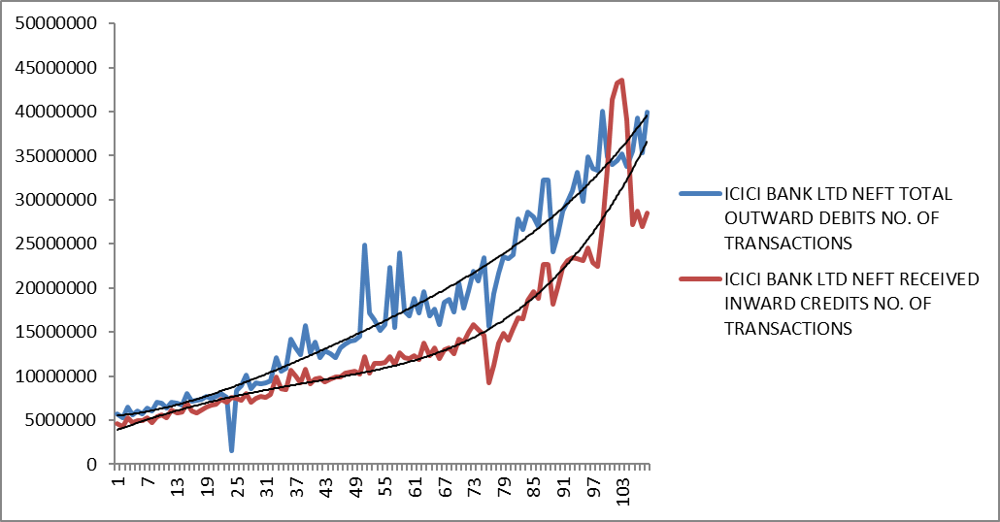
From the graph, we have observed that the trend of the outwards of debit and credit is increasing. The trend of the transactions of outwards of credit is inferior than debit.
The equation of trend line for the NEFT transactions of total outward debits is given by: y = 0.3948t⁴ - 70.626t³ + 5627.7t² + 34522t + 5E+06

Here, R² = 0.9445 which is close to 1. So, this model is adequate and the variation in response y explains the 94.45%.
Month | Forecasted Value
January 2023 NEFT outward debit | 39892126
February 2023 NEFT outward debit | 40692052
March 2023 NEFT outward debit | 41513947

The equation of trend line for the NEFT transactions of total outward debits is given by: y = 0.3597t⁴ - 16.003t³ – 1547t² + 204816t + 4E+06
Here, R² = 0.8846 which is close to 1. So, this model is adequate and the variation in response y explains the 88.46%
Month | Forecasted Value
January 2023 NEFT inward credit | 38001818
February 2023 NEFT inward credit | 39181344
March 2023 NEFT inward credit | 40399443

The trend of the RTGS Inward (volume) customer& Outward volume customer month wise for ICICI Bank.
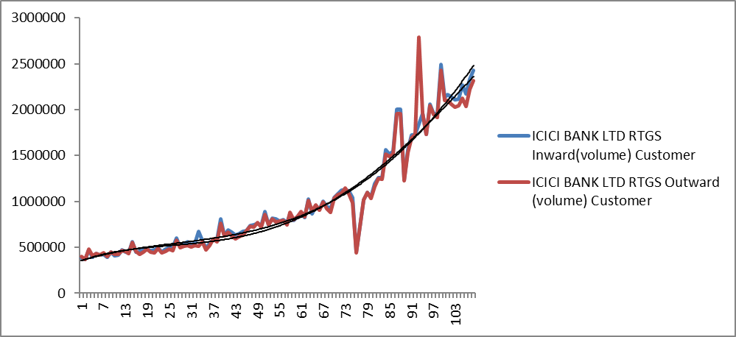

From the graph, we have observed that the trend of the inward (volume) customer and outward (volume) customer is increasing. The trend of the transactions of outwards of volume is same as inwards of volume.
The equation of trend line for the RTGS transactions of total inward volume is given by:
y = -0.007t⁴ + 4.1398t³ - 299.56t² + 12683t + 342963
Here, R² = 0.9428 which is close to 1. So, this model is adequate and the variation in response y explains the 94.28%.

Month | Forecasted Value
January 2023 RTGS inward debit | 2539393
February 2023 RTGS inward debit | 2598621
March 2023 RTGS inward debit | 2658967

The equation of trend line for the RTGS transactions of total outward volume is given by:
y = -0.0299t⁴ + 8.248t³ - 509.14t² + 15203t + 339302
Here, R² = 0.9138 which is close to 1. So, this model is adequate and the variation in response y explains the 91.38 %.
Month | Forecasted Value
January 2023 RTGS outward debit | 2408107
February 2023 RTGS outward debit | 2451467
March 2023 RTGS outward debit | 2494911

The trend for Mobile Banking volume (actual) Corresponding to months for ICICI Bank.

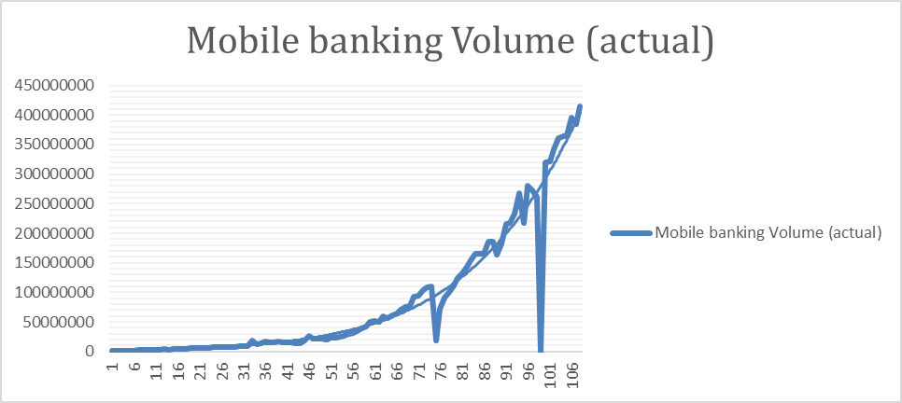

From the graph, we have observed that the trend of the volume (actual) is increasing.
The equation of trend line for Mobile Banking Volume(actual) given by :
y = 5.9793t⁴ - 608.31t³ + 35039t² – 516484t + 4E+06
Here R² = 0.926 which is close to 1. So, this model is adequate and the variation in response y explains the 92.6 %.
Month | Forecasted Value
January 2023 Mobile Banking volume | 477062744
February 2023 Mobile Banking volume | 494257087
March 2023 Mobile Banking volume | 511988230

AXIS BANK
- The trend of NEFT transactions for the total outward debits and total inward credits month wise.
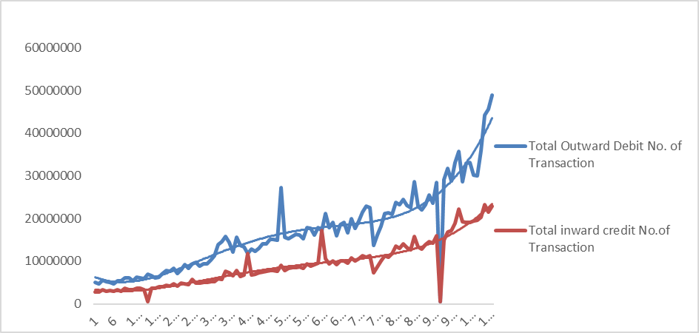

From the graph, we have observed that the trend of the outwards of debit and credit is increasing. The trend of the transactions of outwards of credit is inferior than debit.
.The equation of trend line for the NEFT transactions of total outward debits is given by:
y = 2.568t⁴ - 490.7t³ + 29852t² – 394316t + 7E+06
Here R² = 0.8711 which is close to 1. So, this model is adequate and the variation in response y explains the 87.11 %.
Month | Forecasted Value
January 2023 NEFT outward debit | 45714595.15
February 2023 NEFT outward debit | 47693620
March 2023 NEFT outward debit | 4978136

The equation of trend line for NEFT transactions of total Inward credits is given by : y = 1.0472t⁴ - 198.55t³ + 12353t² – 153181t + 3E+06
Here R² = 0.8747 which is close to 1. So, this model is adequate and the variation in response y explains the 87.47 %.
Month | Forecasted Value
January 2023 NEFT inward credit | 23762082.25
February 2023 NEFT inward credit | 24671892
March 2023 NEFT inward credit | 25627420.29

This is the trend for RTGS Inward (volume) customer & Outward volume customer Corresponding to months.

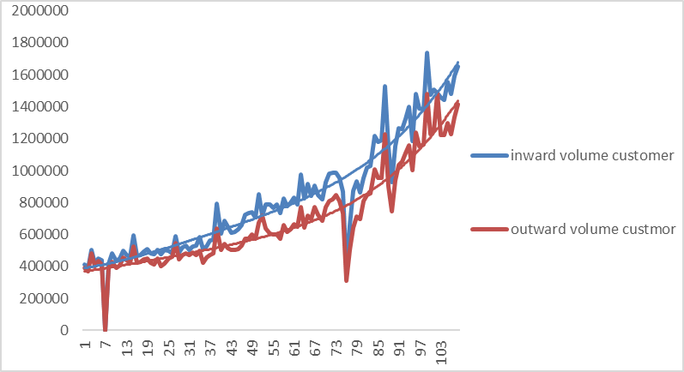

From the graph, we have observed that the trend of the inward (volume) customer and outward (volume) customer is increasing. The trend of the transactions of outwards of volume is inferior than inward .
The equation of trend line for the RTGS transactions of total inward volume is given by:
y = 0.0158t⁴ - 2.2112t³ + 137.24t² + 2978.3t + 387860
Here, R² = 0.9057 which is close to 1. So, this model is adequate and the variation in response y explains the 90.57%.
Month | Forecasted Value
January 2023 RTGS inward debit | 1709773.959
February 2023 RTGS inward debit | 1746247.8
March 2023 RTGS inward debit | 1783830.921

The equation of trend line for the RTGS transactions of total outward volume is given by:
y = 0.0108t⁴ - 1.0148t³ + 47.957t² + 2911.3t + 366876
Here R² = 0.8896 which is close to 1. So, this model is adequate and the variation in response y explains the 88.96%.
Month | Forecasted Value
January 2023 RTGS outward debit | 1464297.527
February 2023 RTGS outward debit | 1497927.9
March 2023 RTGS outward debit | 1532552.601

- This is the trend for Mobile Banking volume (actual) Corresponding to months.

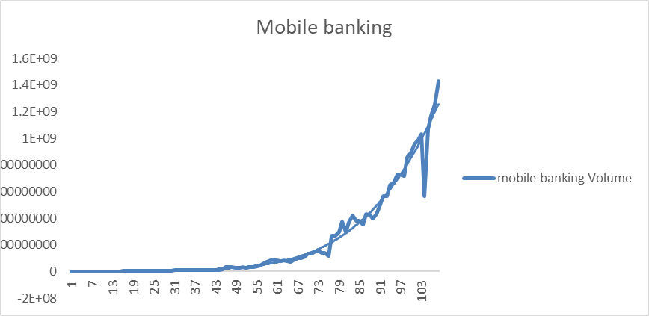

From the graph, we have observed that the trend of the volume (actual) is increasing.
The equation of trend line for Mobile Banking Volume(actual) given by:
y = 26.718t4 - 2866.2t3 + 122207t2 - 2E+06t + 9E+06
Here R² = 0.9708 which is close to 1. So, this model is adequate and the variation in response y explains the 97.08 %.
Month | Forecasted Value
January 2023 Mobile Banking volume | 1302592993
February 2023 Mobile Banking volume | 1364574880
March 2023 Mobile Banking volume | 1428788996

HDFC BANK
- This is the trend for NEFT No Of Transactions Of Total outward Debits & Total inward Credits Corresponding to months.
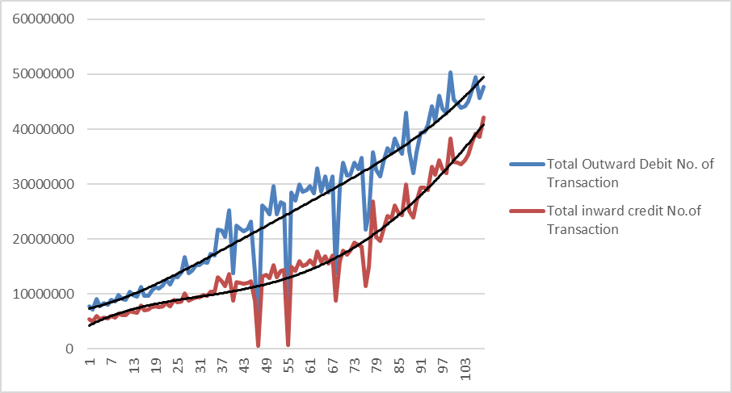
From the graph, we have observed that the trend of the outwards of debit and credit is increasing. The trend of the transactions of outwards of credit is inferior than debit.
The equation of trend line for the NEFT transactions of total outward debits is given by:
y=0.4829t⁴-96.276t³+7158.1t²+132579t+7E+06
Here R² = 0.8877 ,which is close to 1. So, this model is adequate and the variation in response y explains the 88.77%.
Month | Forecasted Value
January 2023 NEFT outward debit | 49981561.04
February 2023 NEFT outward debit | 50754733
March 2023 NEFT outward debit | 51548797.04

The equation of trend line for the NEFT transactions of total outward debits is given by
y=-0.3331t⁴+117.2t³-8885.7t²+353682t+4E+06
Here, R² = 0.9365 which is close to 1. So, this model is adequate and the variation in response y explains the 93.65%
Month | Forecasted Value
January 2023 NEFT inward credit | 41737951.67
February 2023 NEFT inward credit | 42612079
March 2023 NEFT inward credit | 43497420.14

- This is the trend for RTGS Inward (volume) customer& Outward volume customer month wise.

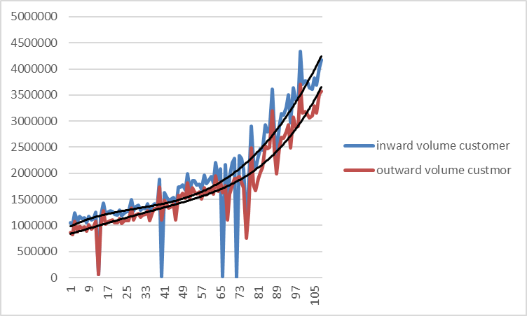

From the graph, we have observed that the trend of the inward (volume) customer and outward (volume) customer is increasing. The trend of the transactions of outwards of volume is inferior than inward .
The equation of trend line for the RTGS transactions of total inward volume is given by:
y = -0.0108t⁴ + 6.8889t³ - 548.43t² + 22964t + 957158
Here, R² = 0.8179 which is close to 1. So, this model is adequate and the variation in response y explains the 81.79%.

Month | Forecasted Value
January 2023 RTGS inward debit | 4341154.309
February 2023 RTGS inward debit | 4435092.9
March 2023 RTGS inward debit | 4530913.123

The equation of trend line for the RTGS transactions of total outward volume is given by:
y = 0.0344t⁴ - 3.3604t³ + 90.766t² + 12166t + 827575
Here, R² = 0.8863 which is close to 1. So, this model is adequate and the variation in response y explains the 88.63%.
Month | Forecasted Value
January 2023 RTGS outward debit | 3747377.786
February 2023 RTGS outward debit | 3839628
March 2023 RTGS outward debit | 3934848.447

- This is the trend for Mobile Banking volume (actual) month wise.

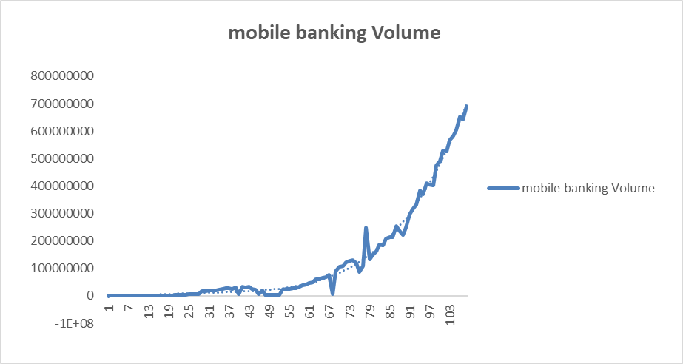

From the graph, we have observed that the trend of the volume (actual) is increasing.
The equation of trend line for Mobile Banking Volume(actual) given by :
y = 12.051t⁴ - 978.41t³ + 21543t² + 409348t - 4E+06
Here R² = 0.9898 which is close to 1. So, this model is adequate and the variation in response y explains the 98.98 %.
Month | Forecasted Value
January 2023 Mobile Banking volume | 730598989.3
February 2023 Mobile Banking volume | 763821780
March 2023 Mobile Banking volume | 798191735.4

Trend Estimation and Forecasting (For Public Bank)
- Trend for NEFT transactions for the total outward debits & total inward credits month wise for CANARA BANK
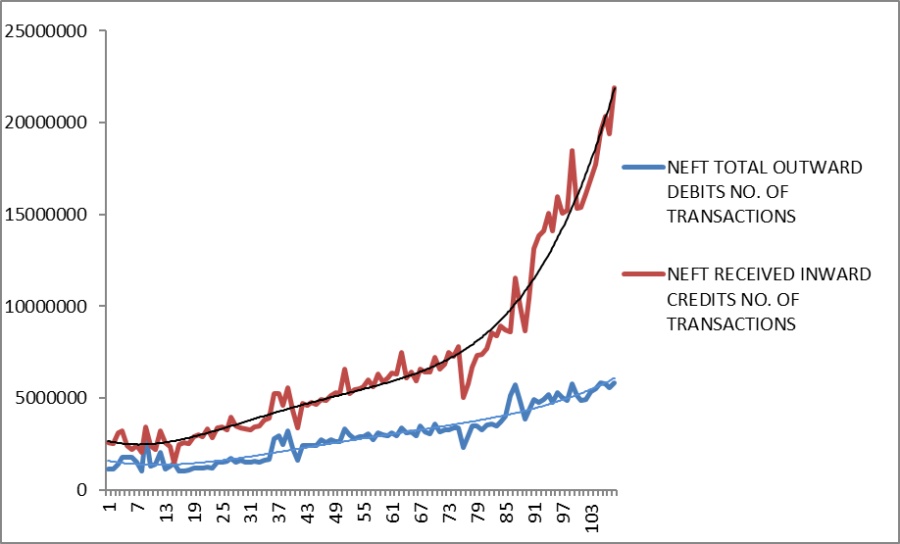
From the graph, we have observed that the trend of the outward of debit and inward credit is increasing. The trend of the transactions of outwards of credit is inferior than debit.
The equation of trend line for the NEFT transactions of total outward debits is given by.
y = 0.7115t⁴ - 115.54t³ + 6553.9t² – 79203t+ 3E+06
Here, R² = 0.9684 which is close to 1. So, this model is adequate and the variation in response y explains the 96.84%
Month | Forecasted value
January 2023 NEFT outward debit | 23040140
February 2023 NEFT outward debit | 23976835
March 2023 NEFT outward debit | 24953692.83
The equation of trend line for the NEFT transactions of received inward credits is given by.
Y=0.1673t⁴ - 35.8t³ + 2760.3t² – 49931t + 2E+06
Here, R² = 0.9065 which is close to 1. So, this model is adequate and the variation in response y explains the 90.65%

Month | Forecasted value
January 2023 NEFT inward credit | 6606367.44
February 2023 NEFT inward credit | 6751813
March 2023 NEFT inward credit | 6903443.46

- Trend for RTGS Inward (volume) customer & outward (volume) customer month wise for CANARA BANK
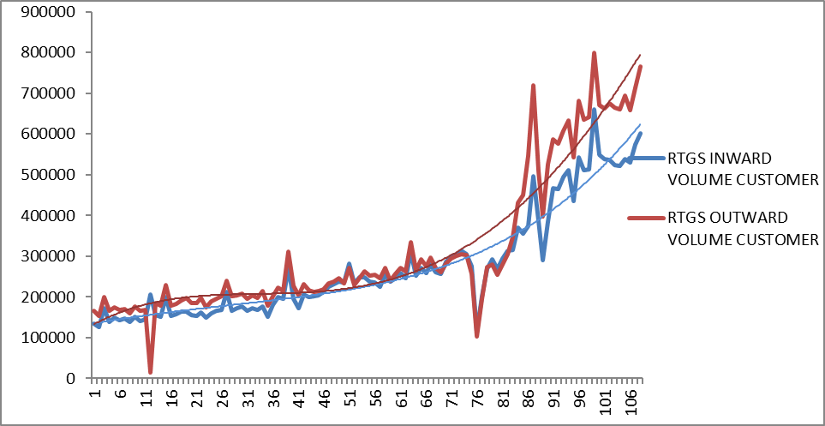
From the graph, we observed that the trend of inward volume customer and outward volume customer is increasing.
The equation of trend line for the RTGS of transaction total inward volume is given by
y = -0.0064t⁴ + 2.6797t³ - 223.66t² + 7153.1t + 126295
Here, R² = 0.8881 which is close to 1. So, this model is adequate and the variation in response y explains the 88.81%
Month | Forecasted value
January 2023 RTGS inward credit | 815555.421
February 2023 RTGS inward credit | 836506.7
March 2023 RTGS inward credit | 857849.968

The equation of trend line for the RTGS of transaction total outward volume is given by.
Y = 0.0033t⁴ + 0.0172t³ – 17.988t² + 2091.7t + 133475
Here, R² = 0.9078 which is close to 1. So, this model is adequate and the variation in response y explains the 90.78%

Month | Forecasted value
January 2023 RTGS outward debit | 635851.302
February 2023 RTGS outward debit | 651953.4
March 2023 RTGS outward debit | 668510.041

- This is the trend for Mobile Banking of volume (actual) month wise
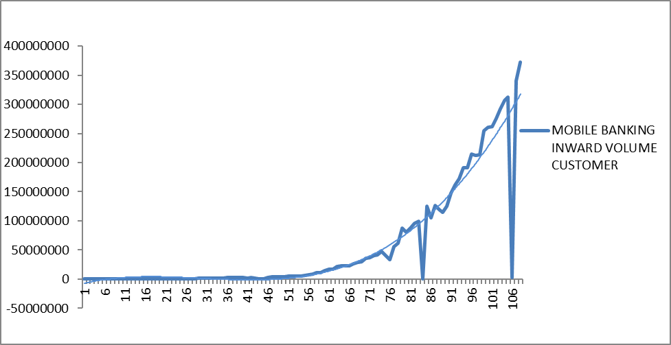
From the graph, we observed that the trend of the volume (actual) is increasing .
The equation of trend line for the MOBILE BANKING volume (actual) is given by
y = -0.7093t⁴ + 848.29t³ – 71379t² + 2E+06t - 9E+06
Here, R² = 0.8783 which is close to 1. So, this model is adequate and the variation in response y explains the 87.83%

Month | Forecasted value
January 2023 Mobile Banking volume | 359382768
February 2023 Mobile Banking volume | 372539477
March 2023 Mobile Banking volume | 386010308

- Trend for NEFT transactions for the total outward debits & total inward credits month wise for STATE BANK OF INDIA
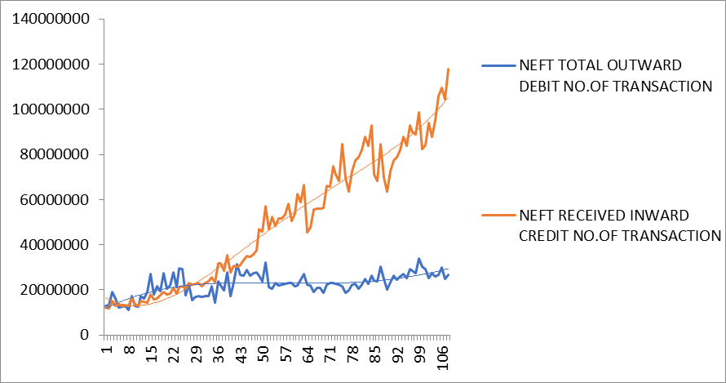

The equation of trend line for the NEFT transaction of total outward debits is given by

y = -0.2859t⁴ + 126.23t³ – 15579t² + 739180t + 1E+07
R² = 0.4699
The equation of trend line for NEFT transaction of total inward credit is given by
y = 2.7227t⁴ - 659.06t³ + 55574t² – 933987t + 2E+07
Here, R² = 0.9586 which is close to 1. So model is adequate and the variation in y is explained by 95.86%

Month | Forecasted value
January 2023 NEFT inward credit | 109299623.2
February 2023 NEFT inward credit | 111128477
March 2023 NEFT inward credit | 113028840.7
- Trend for RTGS Inward (volume) customer & outward (volume) customer month wise for STATE BANK OF INDIA
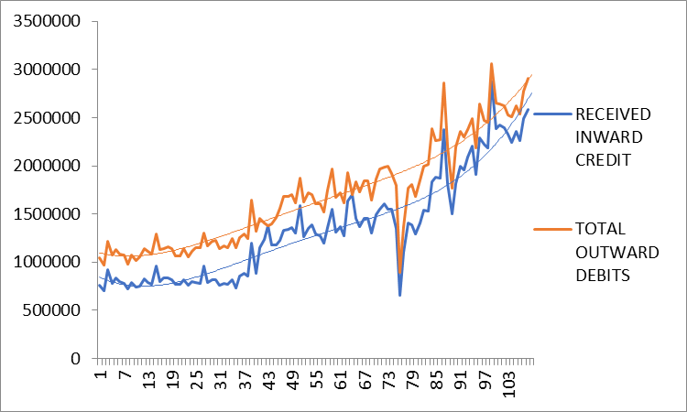

The equation of trend line for the RTGS of transaction total outward volume is given by
y = 0.0559t⁴ - 11.334t³ + 831.8t² – 11463t + 1E+06
Here, R² = 0.8771 which is close to 1. So, this model is adequate and the variation in response y explains the 87.71%

Month | Forecast value
January 2023 RTGS outward debit | 2846031.314
February 2023 RTGS outward debit | 2902615
March 2023 RTGS outward debit | 2961498.638

The equation for trend line for RTGS of transaction total inward volume customer is given by
y = 0.0842t⁴ - 17.052t³ + 1219.6t² – 22028t + 865840
Here, R² = 0.8796 which is close to 1. So, this model is adequate and the variation in response y explains the 87.96%

Month | Forecasted value
January 2023 RTGS inward credit | 2757538.248
February 2023 RTGS inward credit | 2831430
March 2023 RTGS inward credit | 2908732.64

- Trend for Mobile Banking of volume (actual) month wise for STATE BANK OF INDIA
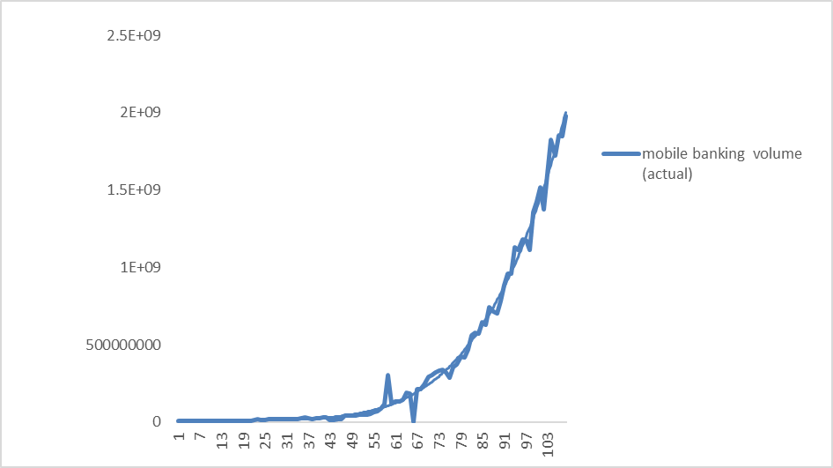

From the graph we observed that the trend of the volume (actual)is increasing

The equation for trend line for Mobile Banking volume (actual) is given by :
y = 31.571t⁴ - 2441.7t³ + 70855t² – 481720t + 6E+06
Here, R² = 0.9929 which is close to 1. So the model is adequate and the variation in response y is explained by 99.29%

Month | Forecasted value
January 2023 Mobile Banking volume | 2089752767
February 2023 Mobile Banking volume | 2182763710
March 2023 Mobile Banking volume | 2278889014

- Trend for NEFT transactions for the total outward debits & total inward credits month wise for BANK OF BARODA.
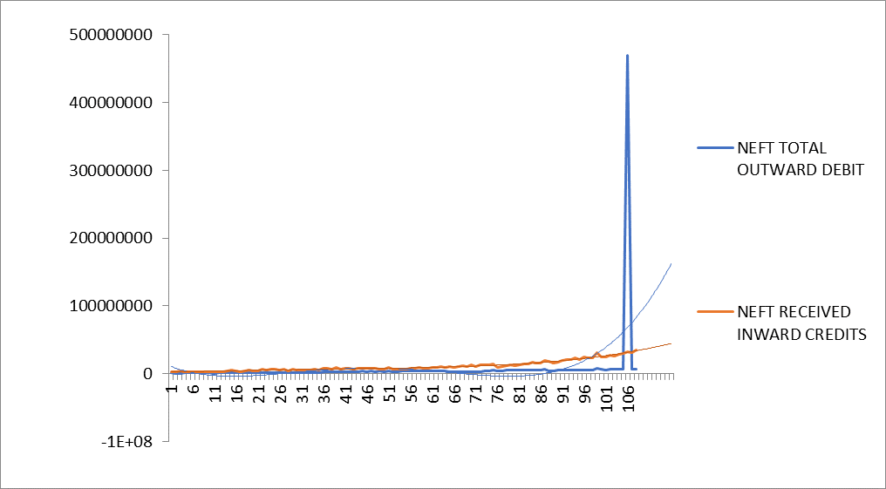
The equation of trend line for the NEFT transaction of total outward debits given by
y = 11.784t⁴ - 2216.3t³ + 132551t² - 3E+06t + 1E+07
R² = 0.1387
The equation Of trend line for NEFT transaction of total inward credits is given by
Y=0.1673t⁴ - 35.8t³ + 2760.3t² – 49931t + 2E+06
Here, R² = 0.9065 Which close to1. So the model Is adequate and variation In response y is explain by 90.65%
Month | Forecasted value
January 2023 NEFT inward credit | 6606367.435
February 2023 NEFT inward credit | 6751813
March 2023 NEFT inward credit | 6903443.459

- Trend for RTGS Inward (volume) customer & outward (volume) customer Month wise for BANK OF BARODA
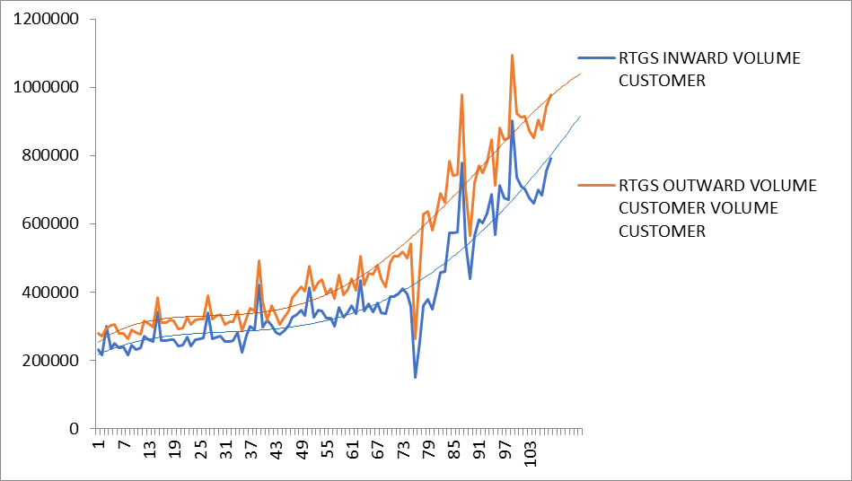
From the graph we observed that the trend inward volume customer and outward volume customer is increasing.

The equation for trend line for RTGS of inward ( volume ) customer is given by :
y = -0.0074t⁴ + 2.5231t³ - 191.35t² + 6047.5t + 210546
Here, R² = 0.8617 which is close to 1 . So the model is adequate and the variation in response y is explained by 86.17%

Month | Forecasted value
January 2023 RTGS inward credit | 819211.4285
February 2023 RTGS inward credit | 835248.1
March 2023 RTGS inward credit | 851492.8227

The equation for trend line for RTGS of outward ( volume ) customer is given by :
y = -0.0233t⁴ + 5.5748t³ - 352.41t² + 9075.8t + 244627
Here , R² = 0.9176 Which is close to 1. So the model is adequate and the variation in response y is explained by 91.76%
Month | Forecasted value
January 2023 RTGS outward debit | 977448.5079
February 2023 RTGS outward debit | 987509.8
March 2023 RTGS outward debit | 997162.4335

- This is the trend for Mobile Banking of volume (actual) month wise for BANK OF BARODA 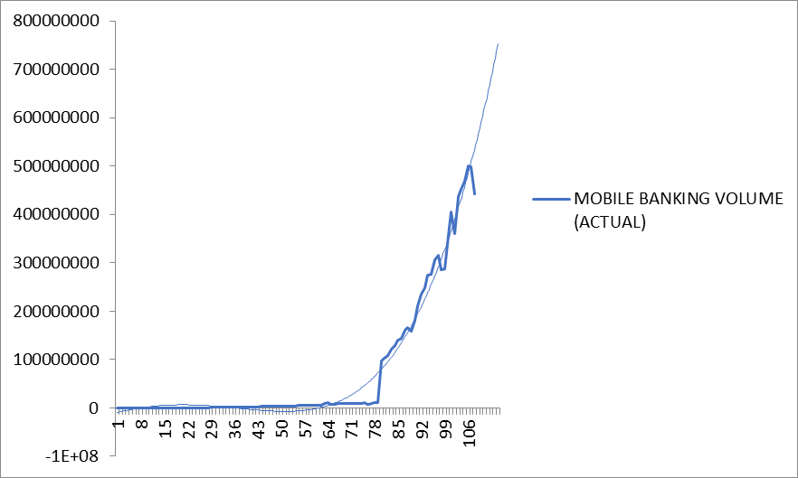

From the graph, we observed that the trend of the volume (actual) is increasing.
The equation for trend line for Mobile Banking of volume (actual) is given by :
y = 8.965t⁴ - 318.05t³ – 39204t² + 2E+06t - 1E+07
Here, R² = 0.9804 which is close to 1. So, the model is adequate and the variation in response y is explained by 98.04%

Month | Forecasted value
January 2023 Mobile Banking volume | 595816215.9
February 2023 Mobile Banking volume | 624872700
March 2023 Mobile Banking volume | 654942599

Conclusion

- There is highly intensity of payments for outward as well inward NEFT, outward as well inward RTGS and MOBILE BANKING in the month of March, October and December for all the three banks.
- The special conclusion from these seasonal indices that there is highly intensity of payments for the bank AXIS bank.
- There is low intensity of payments than private bank.
- The intensity of payments for outward as well inward NEFT, outward as well inward RTGS and MOBILE BANKING in the month of January, February, March, October and December for all the three banks.
- This indicate that there observe seasonal as well financial turnovers variations in seasonal indices.
- There is highly and consistent intensity of payments for the bank CANARA bank.
- Mobile banking is most popular electronic payment way than NEFT and RTGS.
- In private bank AXIS bank has maximum contribution in mobile banking.
- In public bank SBI bank has maximum contribution in mobile banking.
- HDFC bank has maximum contribution in NEFT and RTGC than ICICI and AXIS bank.
- SBI bank has maximum contribution in NEFT and RTGC than CANARA and BARODA bank.

Scope and Limitation
Scope:
- These conclusions may useful to incoming Financial technological companies.

- Also, technological companies may understand reject transactions and % across banks to improve their services.

Limitation:
- There is limitation of use time series tools which are included in undergraduate syllabus for further analysis.

- The time series available for limited time points because the electronic payment is introduced from year 2014.

References:
- Introduction Time Series And Forecasting
(Springer International Edition)
- The Analysis Of Time Series
(Special Indian Edition)
- Discrete Probability Distributions And Time Series
(Nirali Prakashan)

